**Retail Store Management**

**Introduction:**

The main objective of the retail store management is to create an e-commerce application for a retail store where the owner of the store can sell the goods online. The application would allow the admin user which can be either owner or the higher authority of store to manage goods, buyers, and orders. The application also allows, the buyers to purchase goods, place orders and also online payment for the goods. Additionally, it also provides the feature of email subscription to buyers and visitors so that they can receive the latest updates via email. It also sends an automatic email confirmation after completing an order or subscribing to an email list.

* **- Define the information content of your database.**

a)-Define a set of entities and appropriate attributes for each entity. Minimum 10 entities.

* **Entity1:** CATEGORY_TYPE

**Attributes:**

* CATEGORY_ID
* CATEGORY_NAME
* LST_UPDT_DT

**Entity2:** GOODS

**Attributes:**

* GOODS_ID
* GOODS_CODE
* GOODS_DESCRIPTION
* CATEGORY_ID
* GOODS_AMOUNT
* GOODS_QUANTITY
* GOODS_LST_UPDT_DT
* GOODS_NAME

**Entity3:** BUYER

**Attributes:**

* BUYER_ID
* BUYER_EMAIL
* BUYER_FIRST_NAME
* BUYER_LAST_NAME
* BUYER_CONTACT_NO
* BUYER_PASSWORD

**Entity4:** PURCHASE_LINE_ITEM

**Attributes:**

* PURCHASE_LINE_ITEM_ID
* QUANTITY
* GOODS_ID

**Entity5:** BUYER_ORDER

* BUYER_ORDER_ID
* BUYER_ID
* AMOUNT
* DATE_OF_ORDER
* STATUS

**Entity6:** BUYER_ORDER_PURCHASE_LINE_ITEM

**Attributes:**

* BUYER_ORDER_ID
* PURCHASE_LINE_ITEM_ID

**Entity7:** PAYMENT

**Attributes:**

* PAYMENT_ID
* PAYMENT_AMOUNT
* PAYMENT_DATE
* PAYMENT_STATUS
* TRANSACTION_ID
* BUYER_ORDER_ID
* BUYER_ID

**Entity8:** ADMIN**_**ROLES

**Attributes:**

* USER_NAME
* ROLE_NAME

**Entity9:** ADMIN**_**CREDENTIALS

**Attributes:**

* USER_NAME
* PASSWORD

**Entity10:** EMAIL_SUBSCRIBER

**Attributes:**

* EMAIL_SUBSCRIBER_ID
* EMAIL_ID
* FIRST_NAME
* LAST_NAME

b)-Define a set of relationships that might exist between/among entities and attributes. Such relationships may include one-to-one, one-to-many and many-to-many associations.

* **One to One Relationship:**
* EMAIL_SUBSCRIBER – BUYER
* ADMIN_ROLES - ADMIN_CREDENTIALS
* BUYER_ORDER – PAYMENT

**One to Many Relationship:**

* CATEGORY_TYPE – GOODS
* GOODS – PURCHASE_LINE_ITEM

**Many to Many Relationship:**

* PURCHASE_LINE_ITEM - BUYER_ORDER

c)-Define a set of constraints that may be imposed on data.

* Foreign Key Constraint
* Primary Key Constraint
* Not Null
* **Define an E-R Diagram for your database design.**

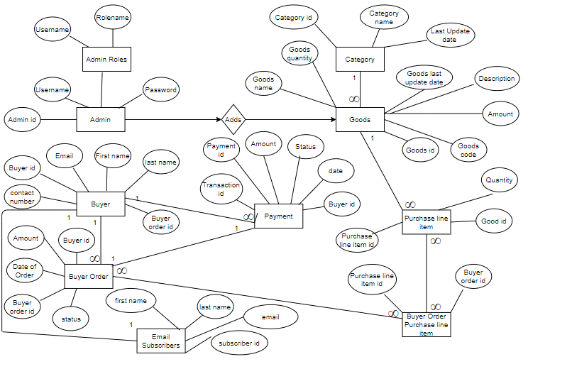

* **- Define a relational schema for your database design.**

Make sure that you have both one-to-many and many-to-many associations.

a)-Define one or more realistic key(s) for every relation scheme. Use both simple and composite keys.

b)-Define a realistic set of Functional / Multi-Valued Dependencies (when appropriate) for every relation scheme.

c)-Check whether your relational schema is in 2NF, 3NF, BCNF, 4NF.

d)-Put your relational schema in the highest normal form that is possible.

Note that, every relation scheme should be in a specific normal form in order to have the relational schema in that normal form.

NOTE: Please provide a detailed explanation for every question when appropriate.

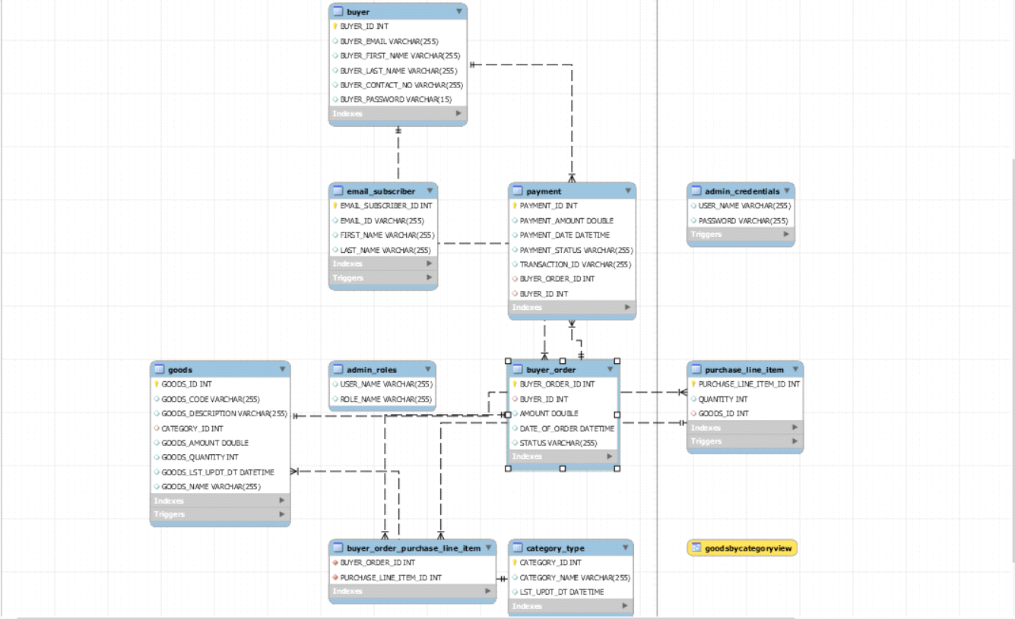

Each entity is represented as a table in the above relational schema model having required primary keys defined individually for each table, and also the foreign keys as and where required.

The above relational schema is in 4NF form.

* **Implementation: Create your database using Oracle, or MySQL, or… to Perform the following operations.**

**A)** You are required to execute SQL queries that include the following operations. For each query, provide the SQL statements along with the output. For each of the following, try different SQL statements (i.e., using one relation, more than one relation,).

* **Create tables:**

CREATE DATABASE RetailStoreManagement;

use RetailStoreManagement;

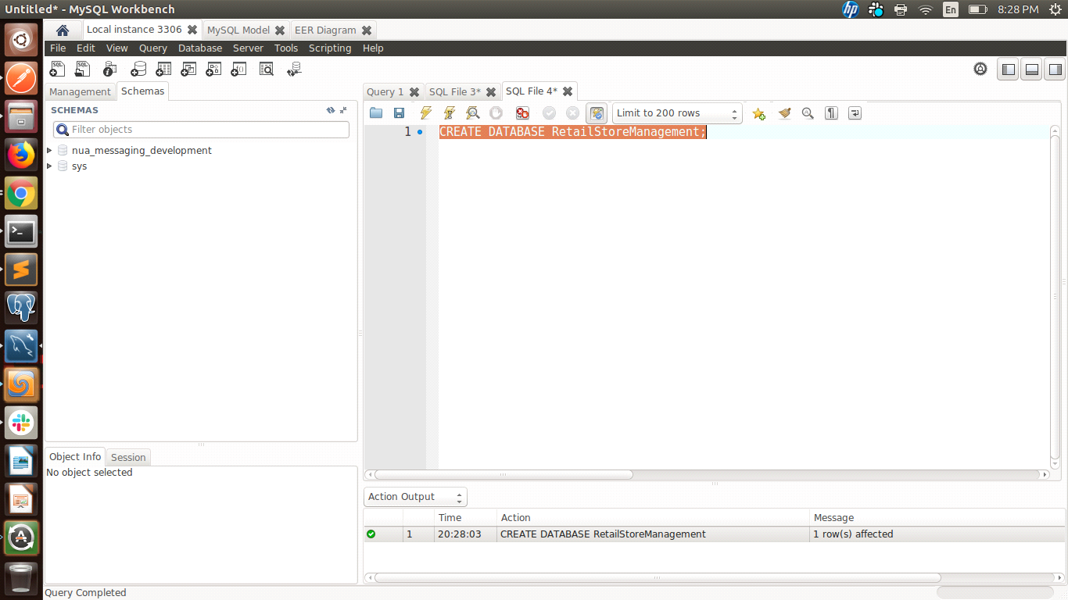

CREATE TABLE CATEGORY_TYPE (

CATEGORY_ID int NOT NULL AUTO_INCREMENT,

CATEGORY_NAME varchar(255) DEFAULT NULL,

LST_UPDT_DT datetime DEFAULT NULL,

PRIMARY KEY (CATEGORY_ID)

);

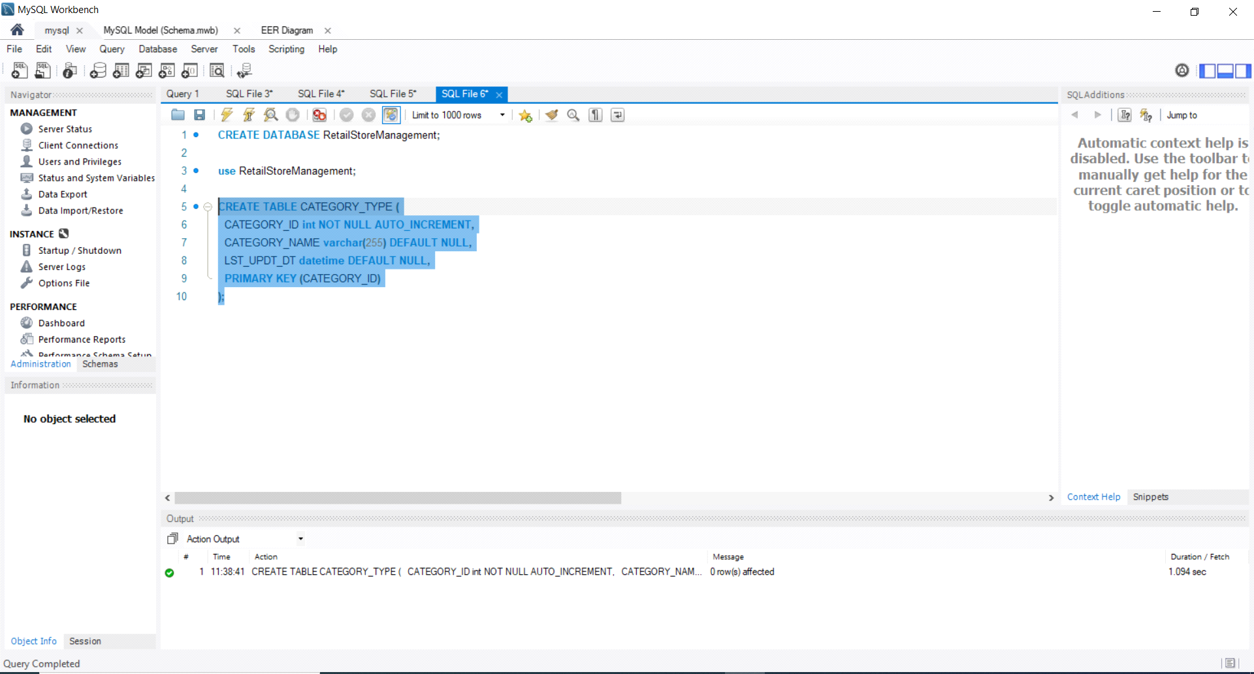

CREATE TABLE GOODS (

GOODS_ID int NOT NULL AUTO_INCREMENT,

GOODS_CODE varchar(255) DEFAULT NULL,

GOODS_DESCRIPTION varchar(255) DEFAULT NULL,

CATEGORY_ID int DEFAULT NULL,

GOODS_AMOUNT double DEFAULT NULL,

GOODS_QUANTITY int DEFAULT NULL,

GOODS_LST_UPDT_DT datetime DEFAULT NULL,

GOODS_NAME varchar(255) DEFAULT NULL,

PRIMARY KEY (GOODS_ID),

FOREIGN KEY (CATEGORY_ID) REFERENCES CATEGORY_TYPE(CATEGORY_ID),

);

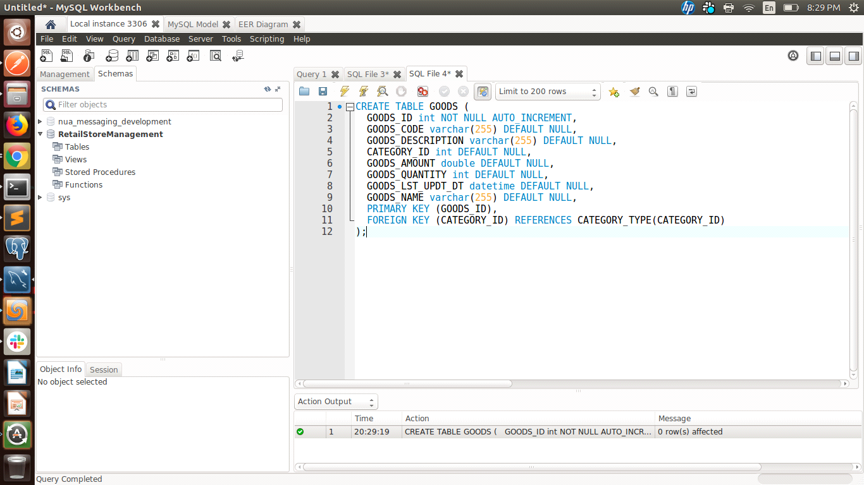

CREATE TABLE BUYER (

BUYER_ID int NOT NULL AUTO_INCREMENT,

BUYER_EMAIL varchar(255) DEFAULT NULL,

BUYER_FIRST_NAME varchar(255) DEFAULT NULL,

BUYER_LAST_NAME varchar(255) DEFAULT NULL,

BUYER_CONTACT_NO varchar(255) DEFAULT NULL,

BUYER_PASSWORD varchar(15) DEFAULT NULL,

PRIMARY KEY (BUYER_ID)

);

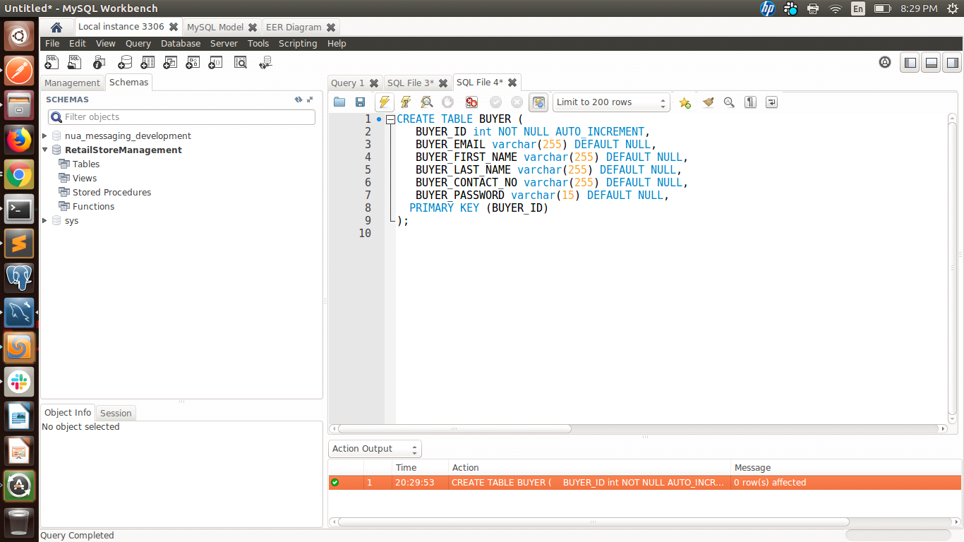

CREATE TABLE PURCHASE_LINE_ITEM (

PURCHASE_LINE_ITEM_ID int NOT NULL AUTO_INCREMENT,

QUANTITY int DEFAULT NULL,

GOODS_ID int DEFAULT NULL,

PRIMARY KEY (PURCHASE_LINE_ITEM_ID),

FOREIGN KEY (GOODS_ID) REFERENCES GOODS(GOODS_ID)

);

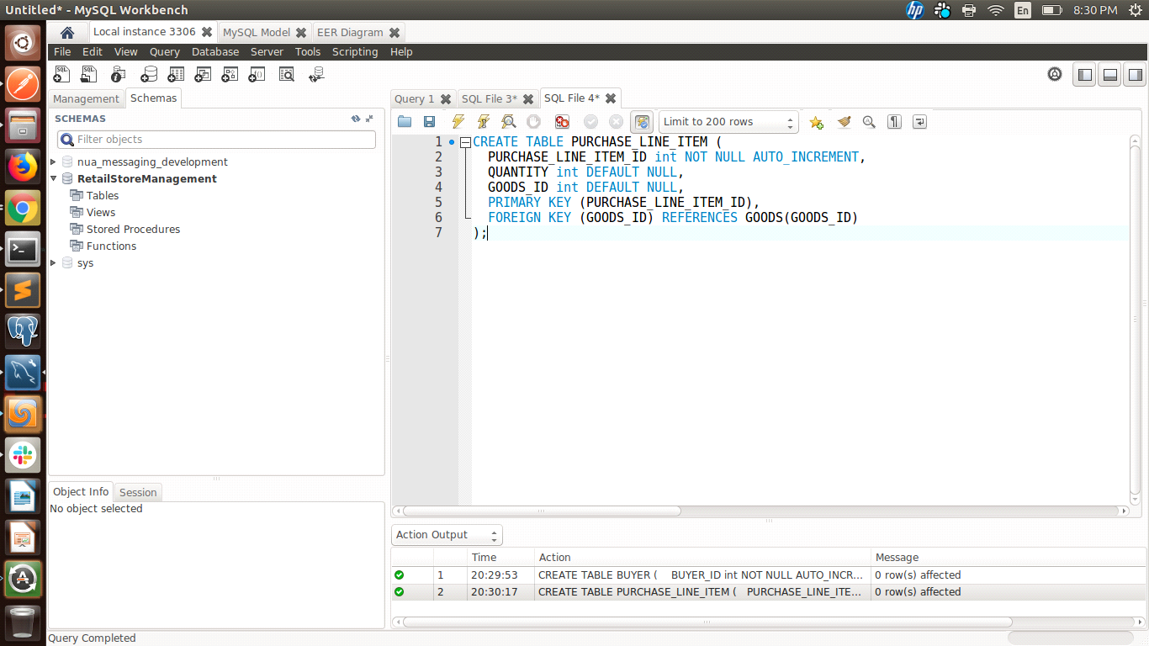

CREATE TABLE BUYER_ORDER (

BUYER_ORDER_ID int NOT NULL AUTO_INCREMENT,

BUYER_ID int DEFAULT NULL,

AMOUNT double DEFAULT NULL,

DATE_OF_ORDER datetime DEFAULT NULL,

STATUS varchar(255) DEFAULT NULL,

PRIMARY KEY (ORDER_ID),

FOREIGN KEY (BUYER_ID) REFERENCES BUYER(BUYER_ID)

);

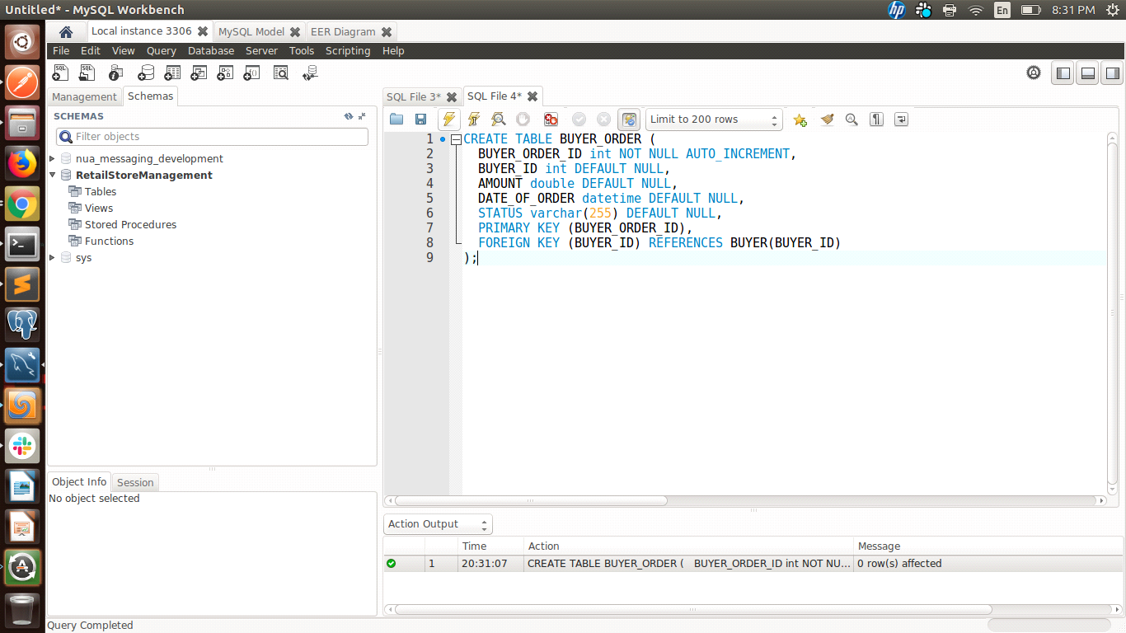

CREATE TABLE BUYER_ORDER_PURCHASE_LINE_ITEM (

BUYER_ORDER_ID int NOT NULL,

PURCHASE_LINE_ITEM_ID int NOT NULL,

FOREIGN KEY (BUYER_ORDER_ID) REFERENCES BUYER_ORDER(BUYER_ORDER_ID),

FOREIGN KEY (PURCHASE_LINE_ITEM_ID) REFERENCES PURCHASE_LINE_ITEM(PURCHASE_LINE_ITEM_ID)

);

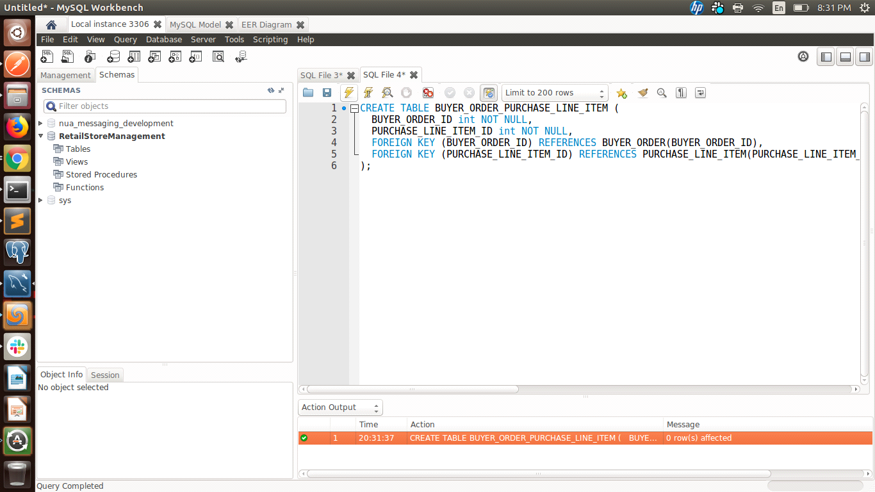

CREATE TABLE PAYMENT (

PAYMENT_ID int NOT NULL AUTO_INCREMENT,

PAYMENT_AMOUNT double DEFAULT NULL,

PAYMENT_DATE datetime DEFAULT NULL,

PAYMENT_STATUS varchar(255) DEFAULT NULL,

TRANSACTION_ID varchar(255) DEFAULT NULL,

BUYER_ORDER_ID int DEFAULT NULL,

BUYER_ID int DEFAULT NULL,

PRIMARY KEY (PAYMENT_ID),

FOREIGN KEY (BUYER_ID) REFERENCES BUYER(BUYER_ID),

FOREIGN KEY (BUYER_ORDER_ID) REFERENCES BUYER_ORDER(BUYER_ORDER_ID)

);

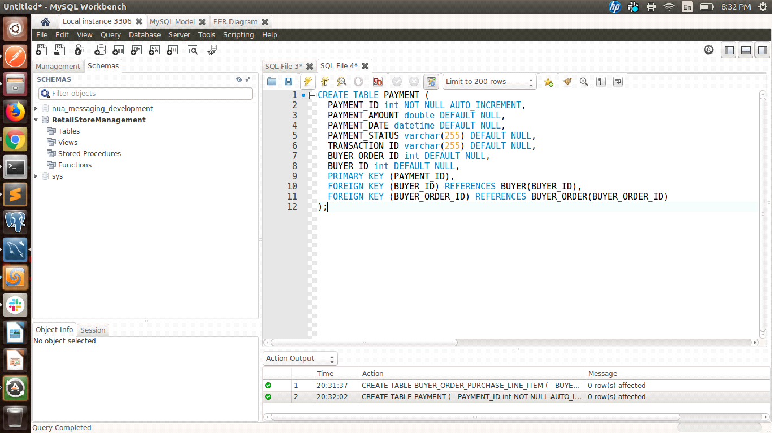

CREATE TABLE ADMIN_ROLES (

USER_NAME varchar(255) DEFAULT NULL,

ROLE_NAME varchar(255) DEFAULT NULL,

);

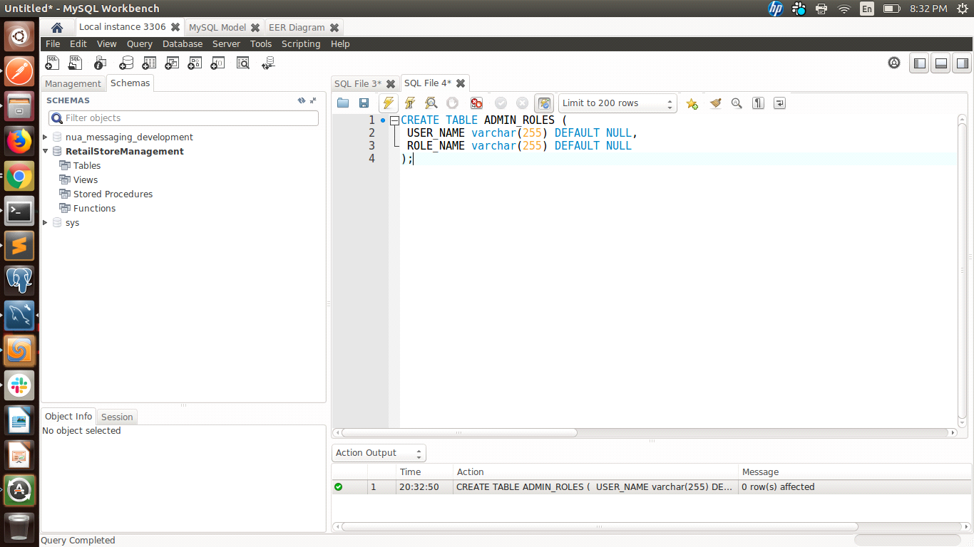

CREATE TABLE ADMIN_CREDENTIALS (

USER_NAME varchar(255) DEFAULT NULL,

PASSWORD varchar(255) DEFAULT NULL,

);

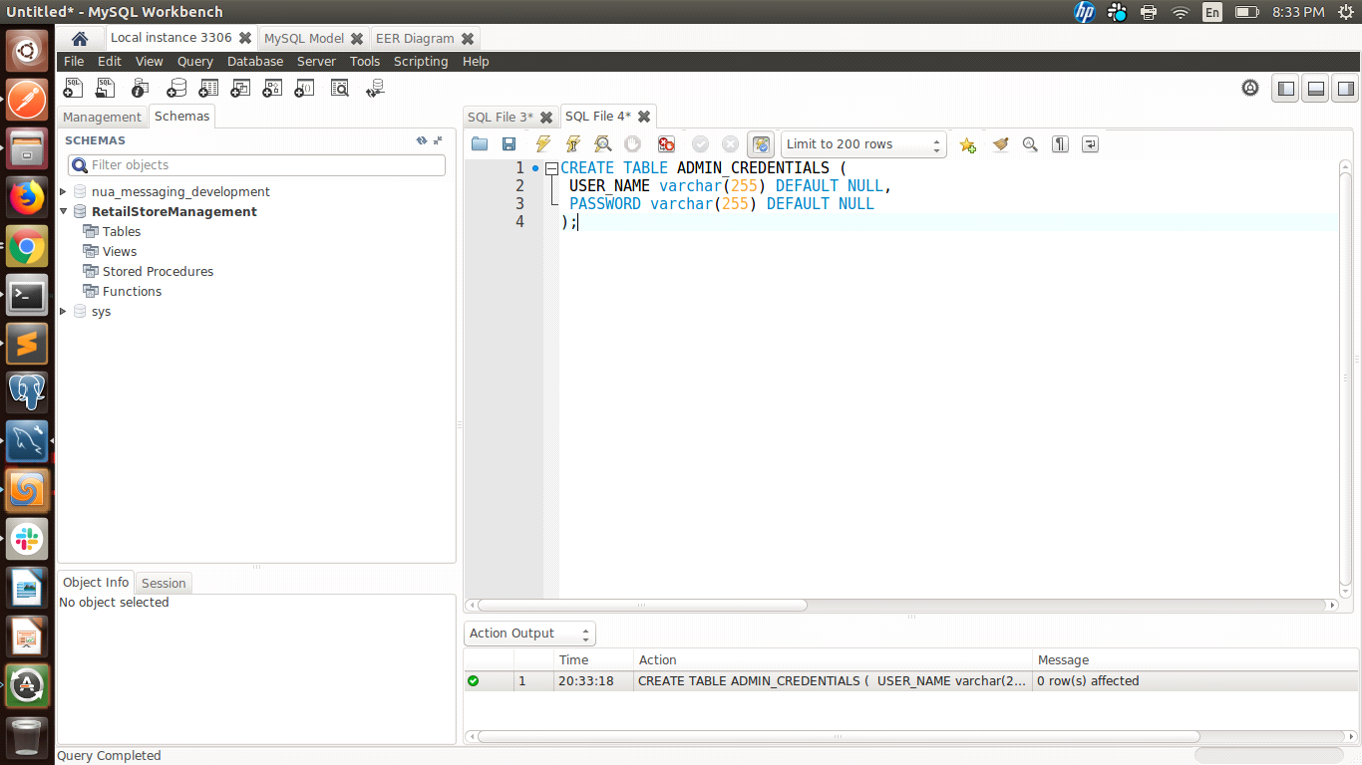

CREATE TABLE EMAIL_SUBSCRIBER (

EMAIL_SUBSCRIBER_ID int NOT NULL AUTO_INCREMENT,

EMAIL_ID varchar(255) DEFAULT NULL,

FIRST_NAME varchar(255) DEFAULT NULL,

LAST_NAME varchar(255) DEFAULT NULL,

PRIMARY KEY (EMAIL_SUBSCRIBER_ID)

);

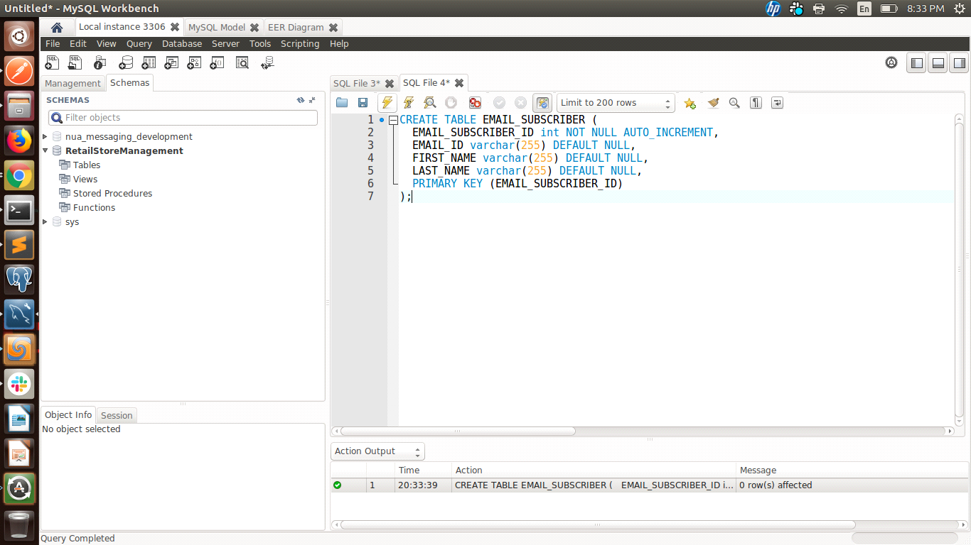

**NOTE: Before executing “Select” Queries need to first execute “Insert” Queries mentioned after the “Select” Queries to get the appropriate output.**

* **Select:** select involving one/more conditions in Where Clause select with aggregate functions (i.e., SUM, MIN, MAX, AVG, COUNT)

select with Having, Group By, Order By clause

Nested Select

select involving the Union operation



Select * from CATEGORY_TYPE;

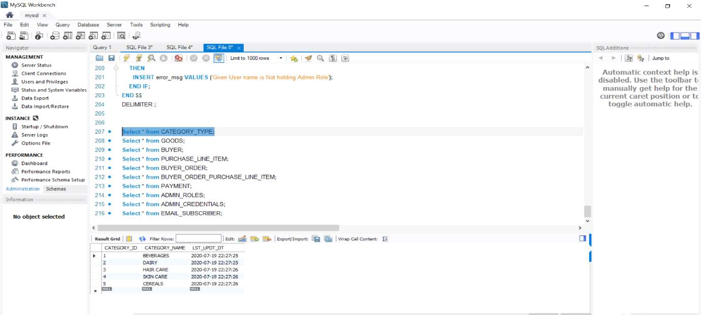

Select * from GOODS;

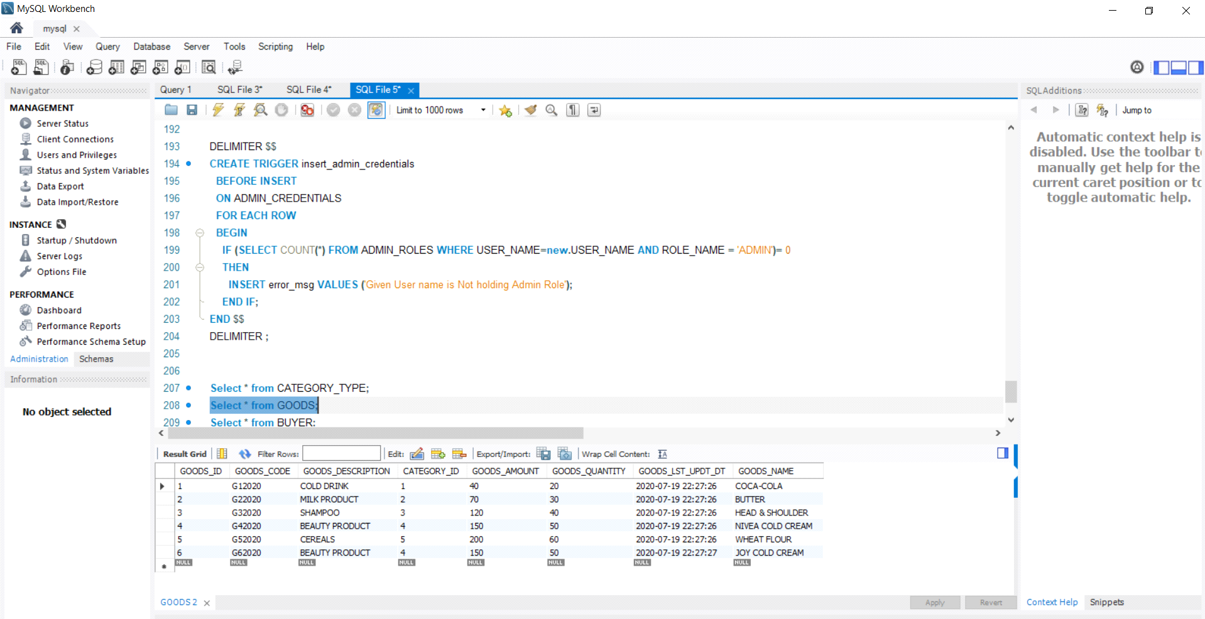

Select * from BUYER;

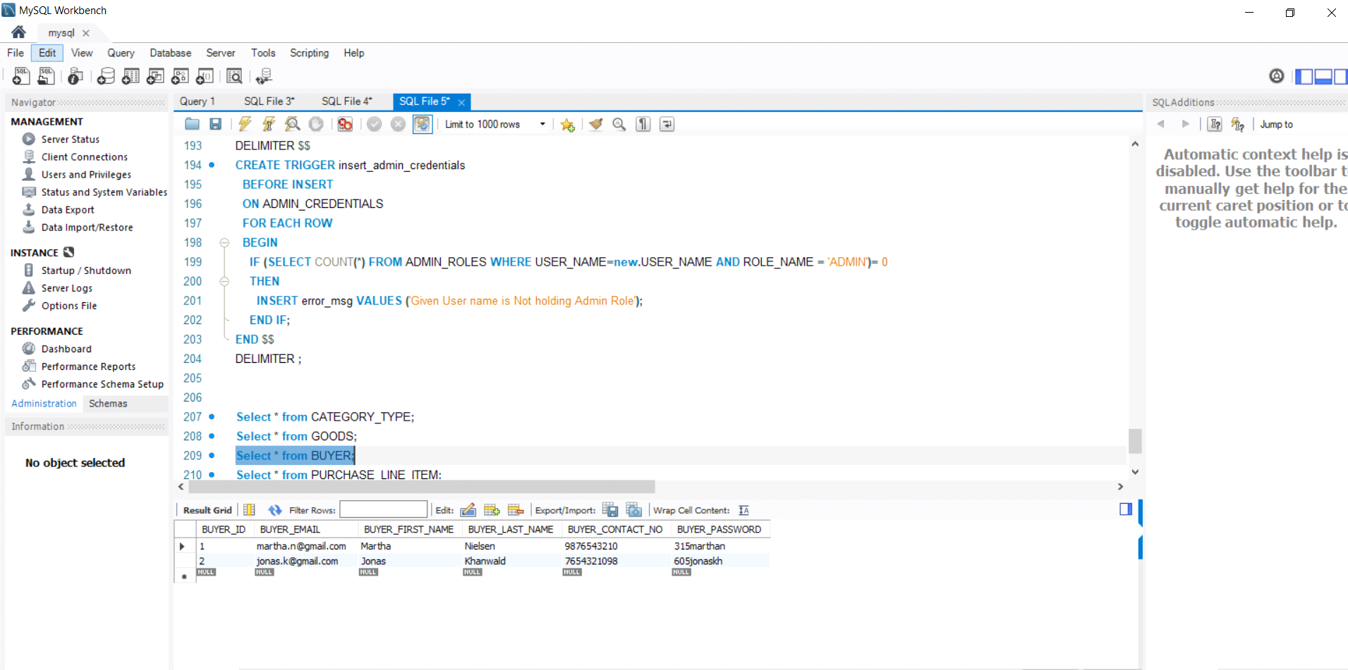

Select * from PURCHASE_LINE_ITEM;

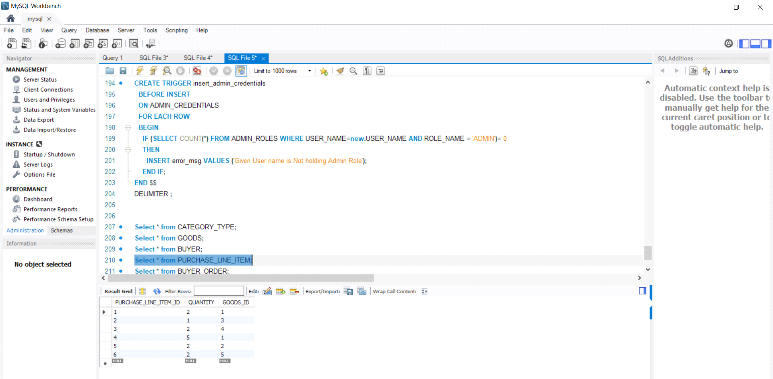

Select * from BUYER_ORDER;

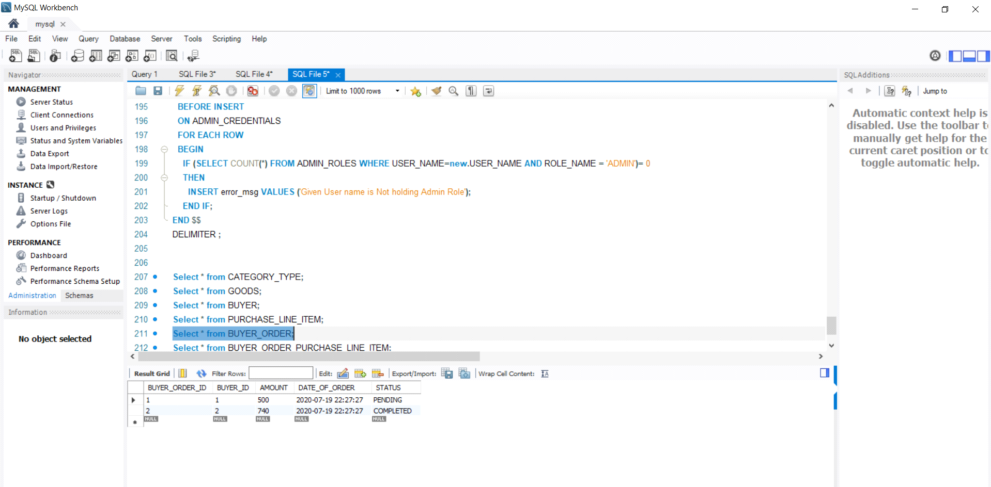

Select * from PAYMENT;

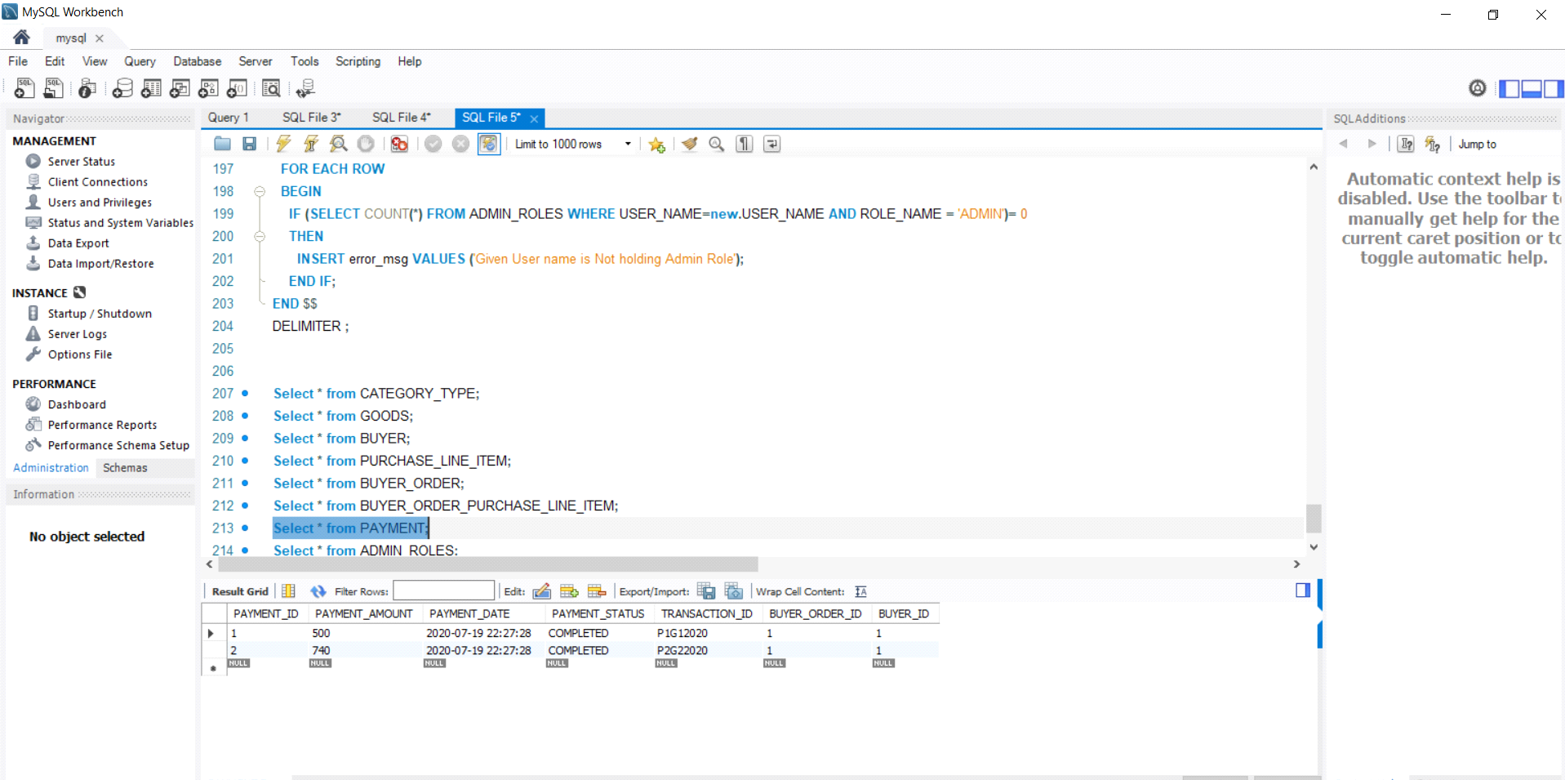

Select * from ADMIN_ROLES;

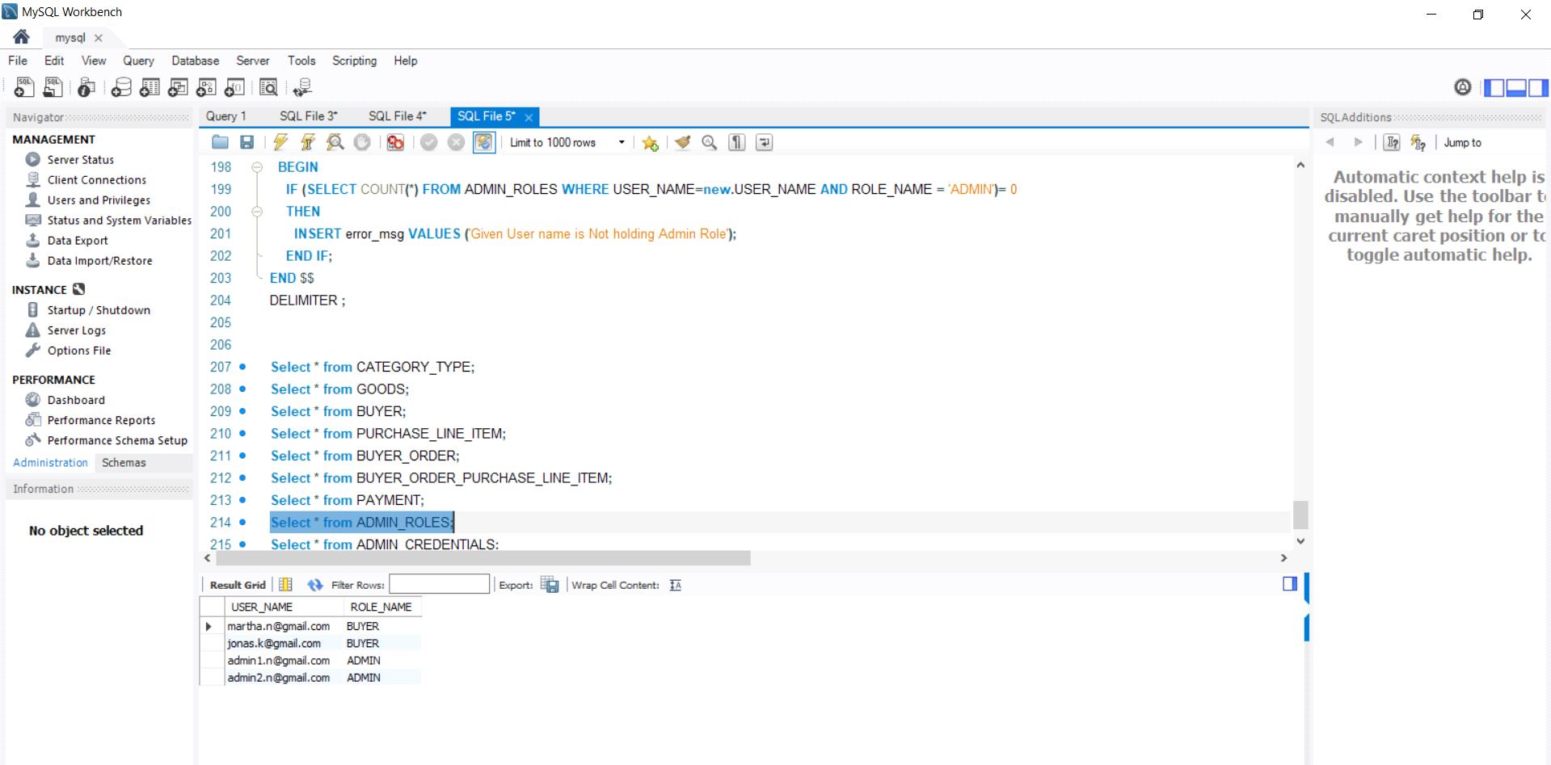

Select * from ADMIN_CREDENTIALS;

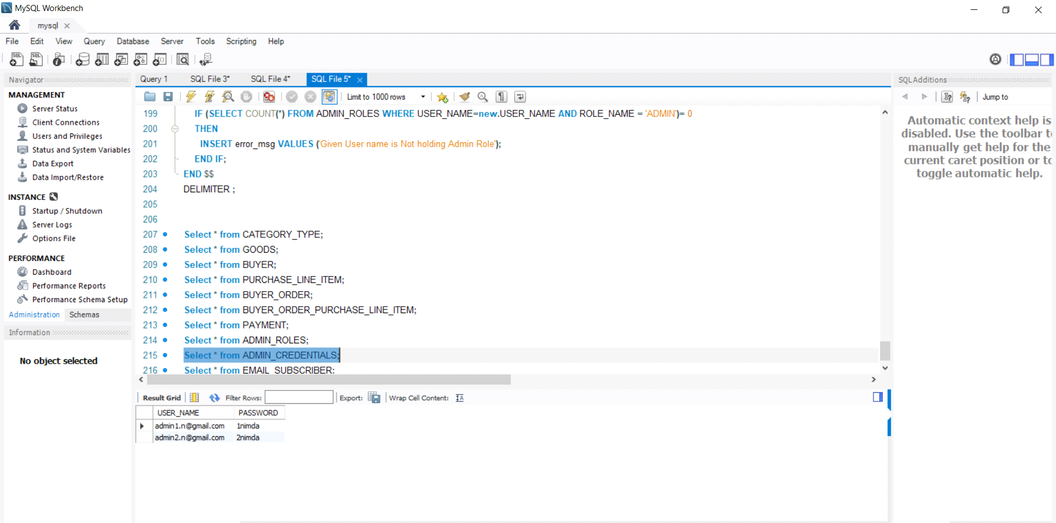

Select * from EMAIL_SUBSCRIBER;

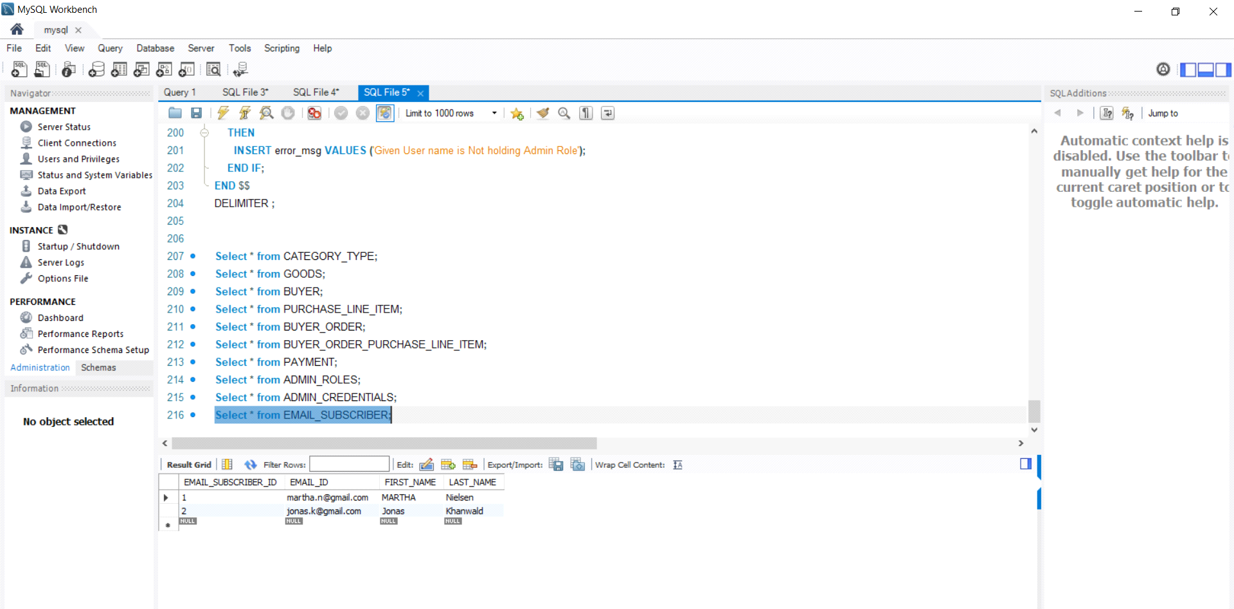

SELECT SUM(PL.QUANTITY * G.GOODS_AMOUNT) FROM PURCHASE_LINE_ITEM PL

LEFT JOIN GOODS G ON G.GOODS_ID = PL.GOODS_ID;

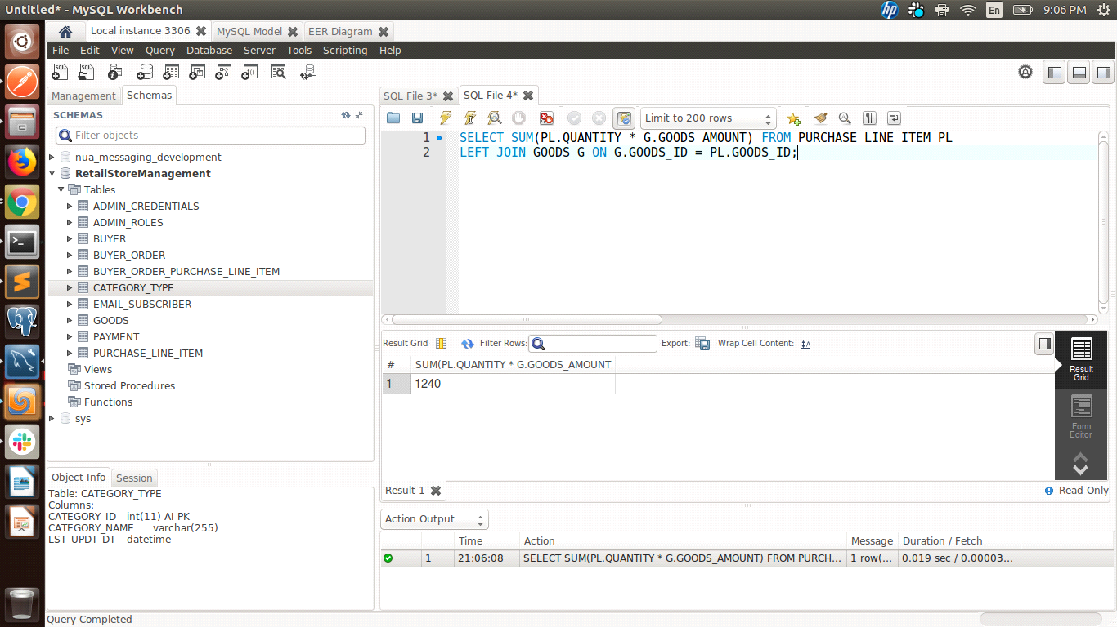

SELECT SUM(GOODS_AMOUNT), CATEGORY_ID FROM GOODS

WHERE CATEGORY_ID = 4

GROUP BY CATEGORY_ID

HAVING COUNT(GOODS_QUANTITY) > 50

ORDER BY CATEGORY_ID ;

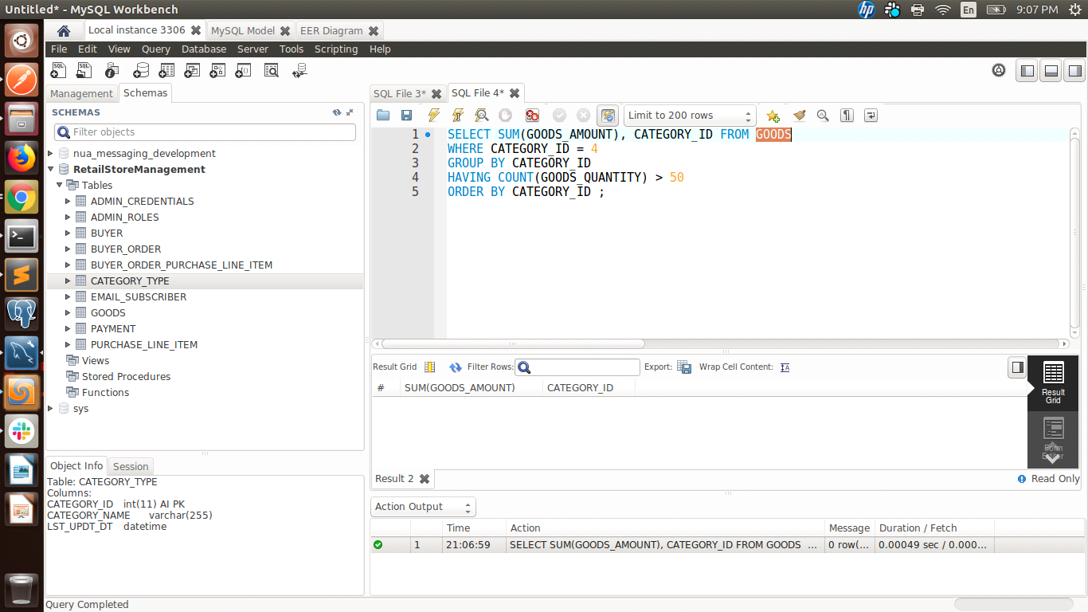

SELECT * FROM PURCHASE_LINE_ITEM

where GOODS_ID IN (

SELECT GOODS_ID FROM GOODS WHERE CATEGORY_ID IN

(

SELECT CATEGORY_ID FROM CATEGORY_TYPE WHERE CATEGORY_NAME = 'CEREALS'

)

);

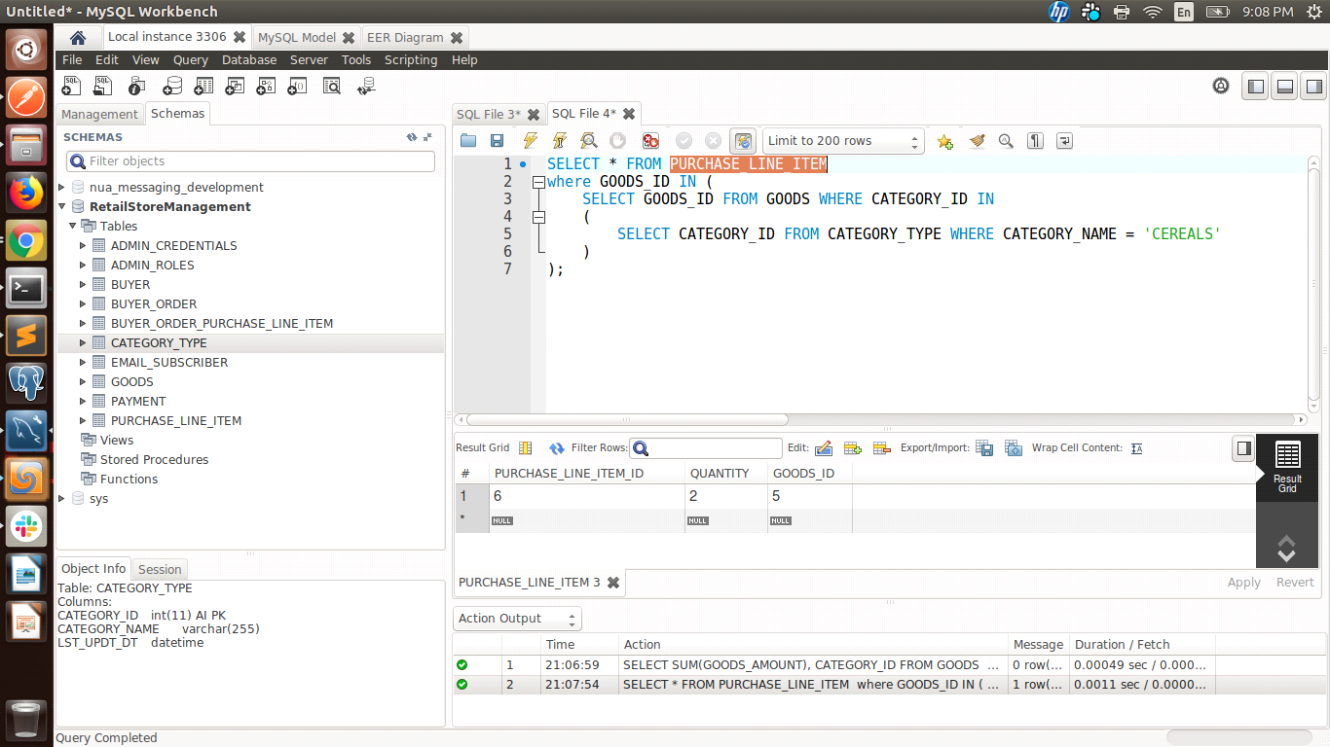

select BUYER_ID

from BUYER_ORDER where AMOUNT < 700

UNION ALL

select BUYER_ID

from BUYER where BUYER_FIRST_NAME = 'Jonas';

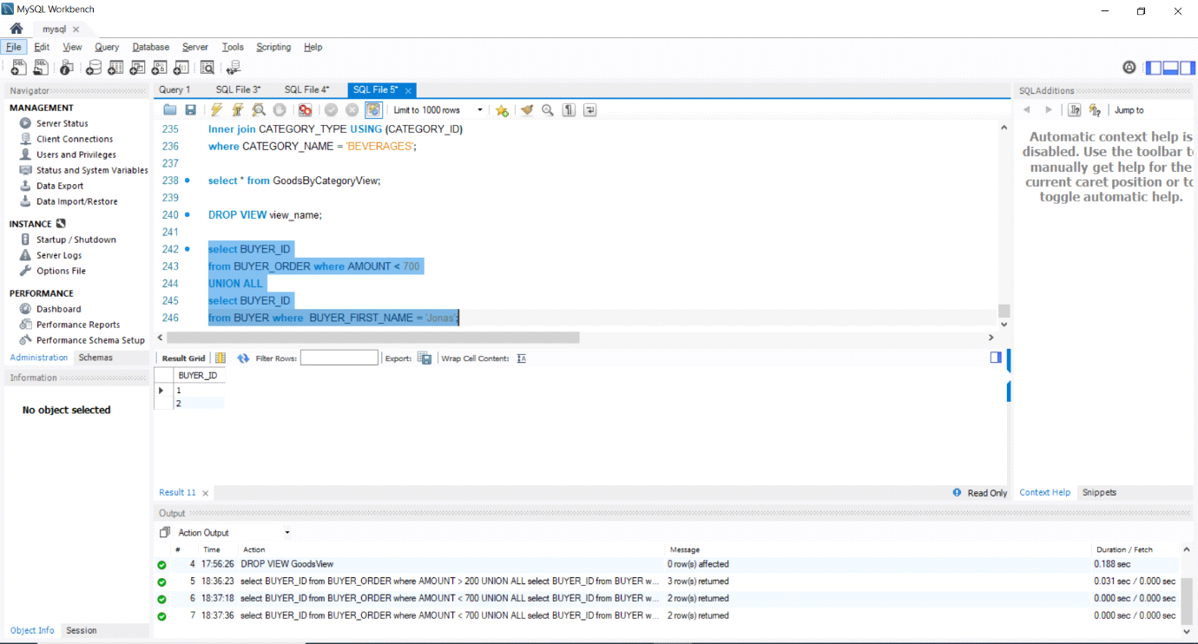

* **Insert:** insert one tuple into a table

insert a set of tuples (by using another select statement)

insert involving two tables

INSERT INTO CATEGORY_TYPE (CATEGORY_NAME, LST_UPDT_DT) VALUES('BEVERAGES',NOW());

INSERT INTO CATEGORY_TYPE (CATEGORY_NAME, LST_UPDT_DT) VALUES('DAIRY',NOW());

INSERT INTO CATEGORY_TYPE (CATEGORY_NAME, LST_UPDT_DT) VALUES('HAIR CARE',NOW());

INSERT INTO CATEGORY_TYPE (CATEGORY_NAME, LST_UPDT_DT) VALUES('SKIN CARE',NOW());

INSERT INTO CATEGORY_TYPE (CATEGORY_NAME, LST_UPDT_DT) VALUES('CEREALS',NOW());

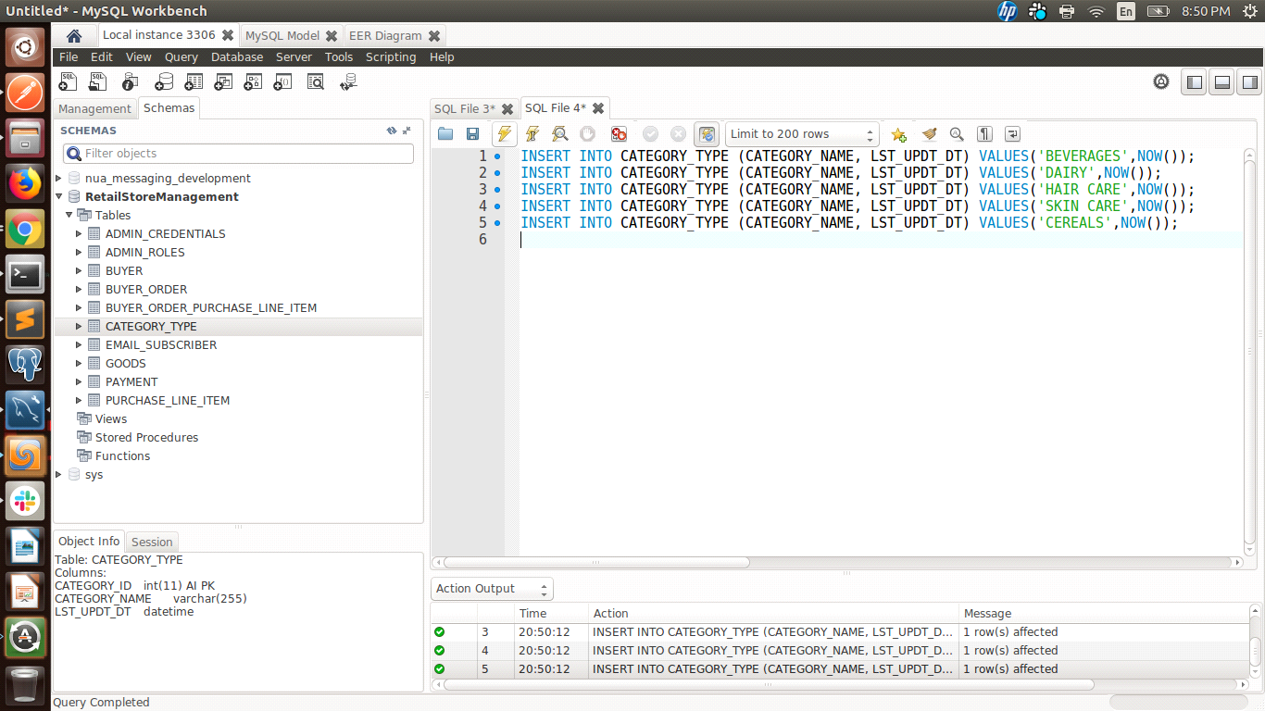

INSERT INTO GOODS (GOODS_CODE,GOODS_DESCRIPTION, CATEGORY_ID, GOODS_AMOUNT, GOODS_QUANTITY, GOODS_LST_UPDT_DT, GOODS_NAME) VALUES('G12020','COLD DRINK',1,40.00,20,now(),'COCA-COLA');

INSERT INTO GOODS (GOODS_CODE,GOODS_DESCRIPTION, CATEGORY_ID, GOODS_AMOUNT, GOODS_QUANTITY, GOODS_LST_UPDT_DT, GOODS_NAME) VALUES('G22020','MILK PRODUCT',2,70.00,30,now(),'BUTTER');

INSERT INTO GOODS (GOODS_CODE,GOODS_DESCRIPTION, CATEGORY_ID, GOODS_AMOUNT, GOODS_QUANTITY, GOODS_LST_UPDT_DT, GOODS_NAME) VALUES('G32020','SHAMPOO',3,120.00,40,now(),'HEAD & SHOULDER');

INSERT INTO GOODS (GOODS_CODE,GOODS_DESCRIPTION, CATEGORY_ID, GOODS_AMOUNT, GOODS_QUANTITY, GOODS_LST_UPDT_DT, GOODS_NAME) VALUES('G42020','BEAUTY PRODUCT',4,150.00,50,now(),'NIVEA COLD CREAM');

INSERT INTO GOODS (GOODS_CODE,GOODS_DESCRIPTION, CATEGORY_ID, GOODS_AMOUNT, GOODS_QUANTITY, GOODS_LST_UPDT_DT, GOODS_NAME) VALUES('G52020','CEREALS',5,200.00,60,now(),'WHEAT FLOUR');

INSERT INTO GOODS (GOODS_CODE,GOODS_DESCRIPTION, CATEGORY_ID, GOODS_AMOUNT, GOODS_QUANTITY, GOODS_LST_UPDT_DT, GOODS_NAME) VALUES('G62020','BEAUTY PRODUCT',4,150.00,50,now(),'JOY COLD CREAM');

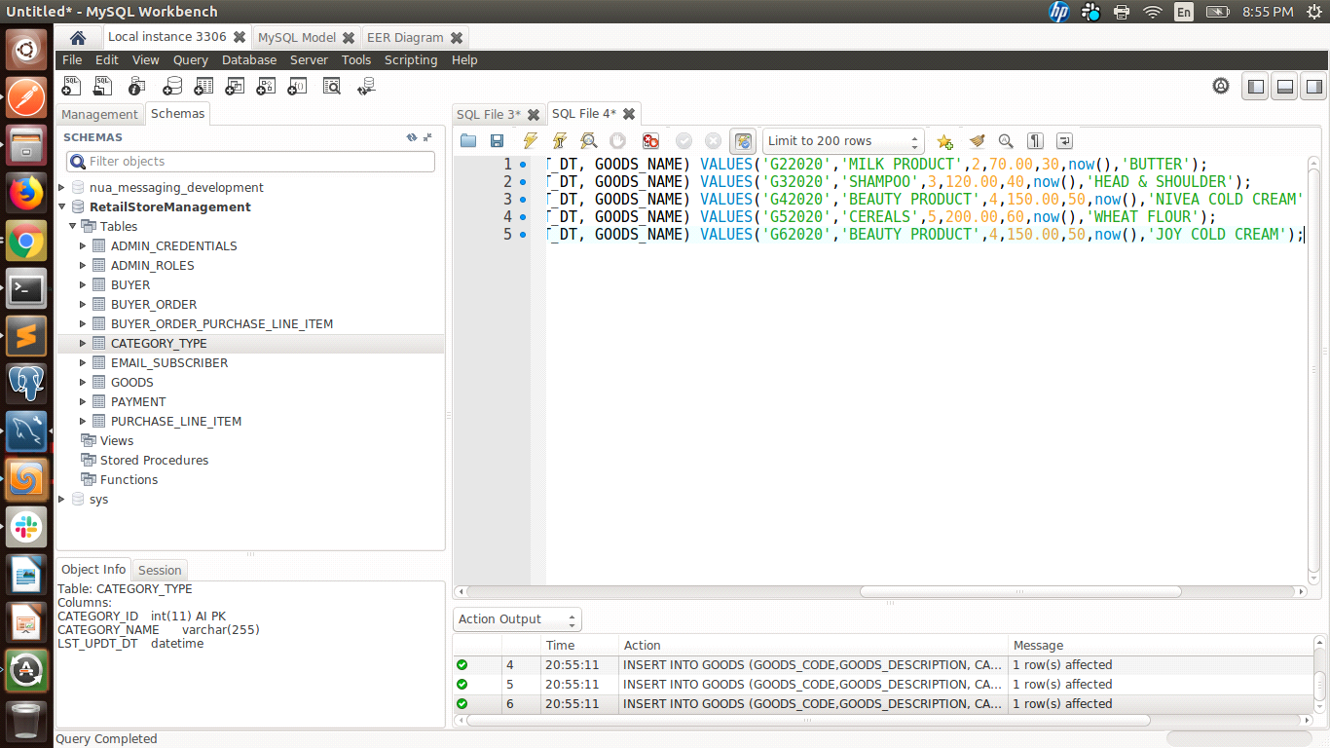

INSERT INTO BUYER (BUYER_EMAIL, BUYER_FIRST_NAME, BUYER_LAST_NAME, BUYER_CONTACT_NO, BUYER_PASSWORD) VALUES('martha.n@gmail.com','Martha','Nielsen','9876543210','315marthan');

INSERT INTO BUYER (BUYER_EMAIL, BUYER_FIRST_NAME, BUYER_LAST_NAME, BUYER_CONTACT_NO, BUYER_PASSWORD) VALUES('jonas.k@gmail.com','Jonas','Khanwald','7654321098','605jonaskh');

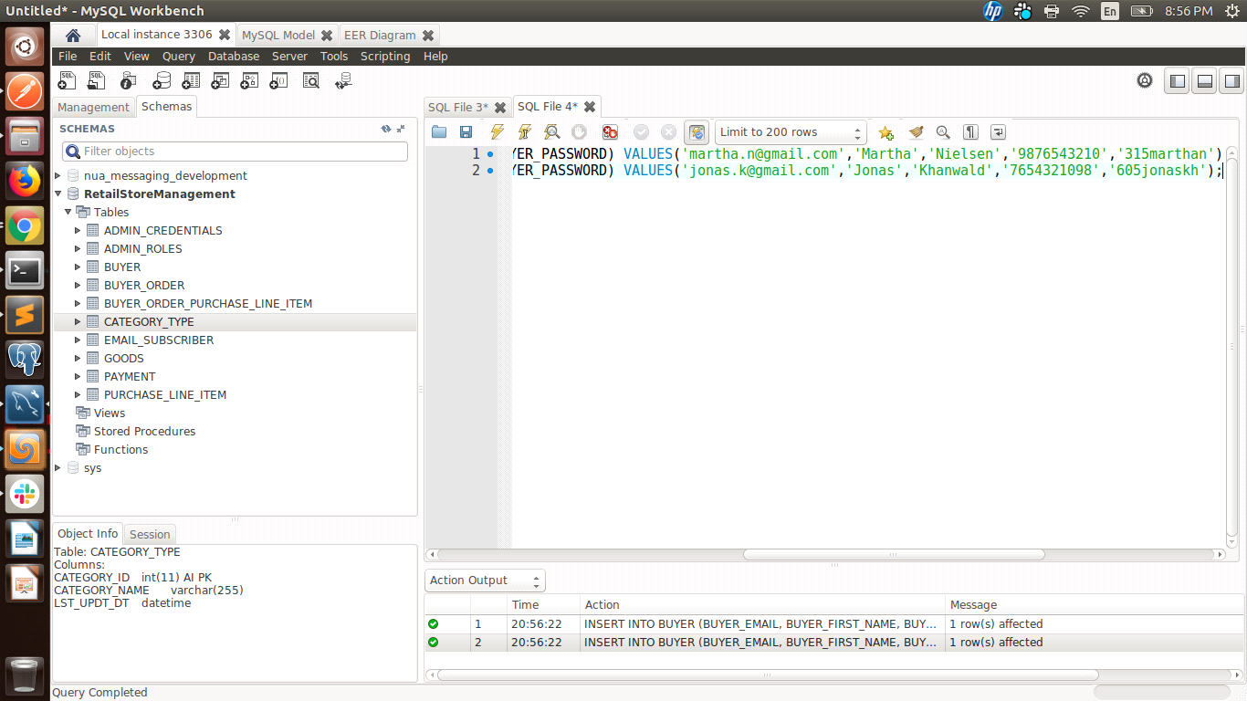

INSERT INTO PURCHASE_LINE_ITEM (QUANTITY, GOODS_ID) VALUES(2,1);

INSERT INTO PURCHASE_LINE_ITEM (QUANTITY, GOODS_ID) VALUES(1,3);

INSERT INTO PURCHASE_LINE_ITEM (QUANTITY, GOODS_ID) VALUES(2,4);

INSERT INTO PURCHASE_LINE_ITEM (QUANTITY, GOODS_ID) VALUES(5,1);

INSERT INTO PURCHASE_LINE_ITEM (QUANTITY, GOODS_ID) VALUES(2,2);

INSERT INTO PURCHASE_LINE_ITEM (QUANTITY, GOODS_ID) VALUES(2,5);

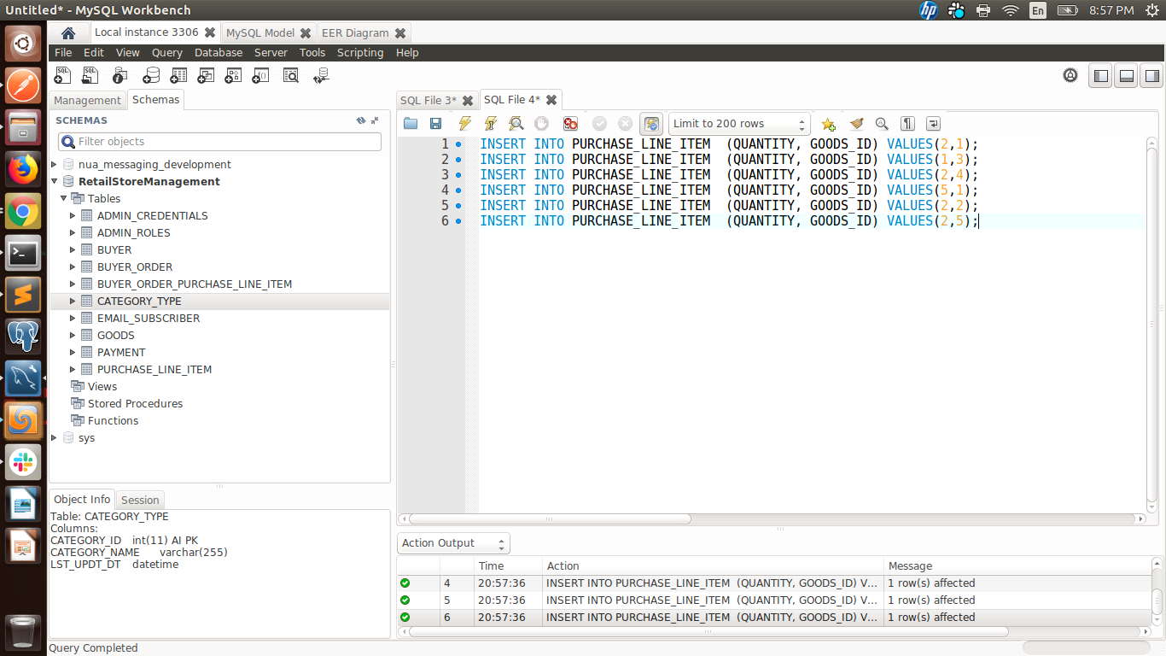

INSERT INTO BUYER_ORDER (BUYER_ID, AMOUNT, DATE_OF_ORDER, STATUS) VALUES (1,500,now(),'PENDING');

INSERT INTO BUYER_ORDER (BUYER_ID, AMOUNT, DATE_OF_ORDER, STATUS) VALUES (2,740,now(),'COMPLETED');

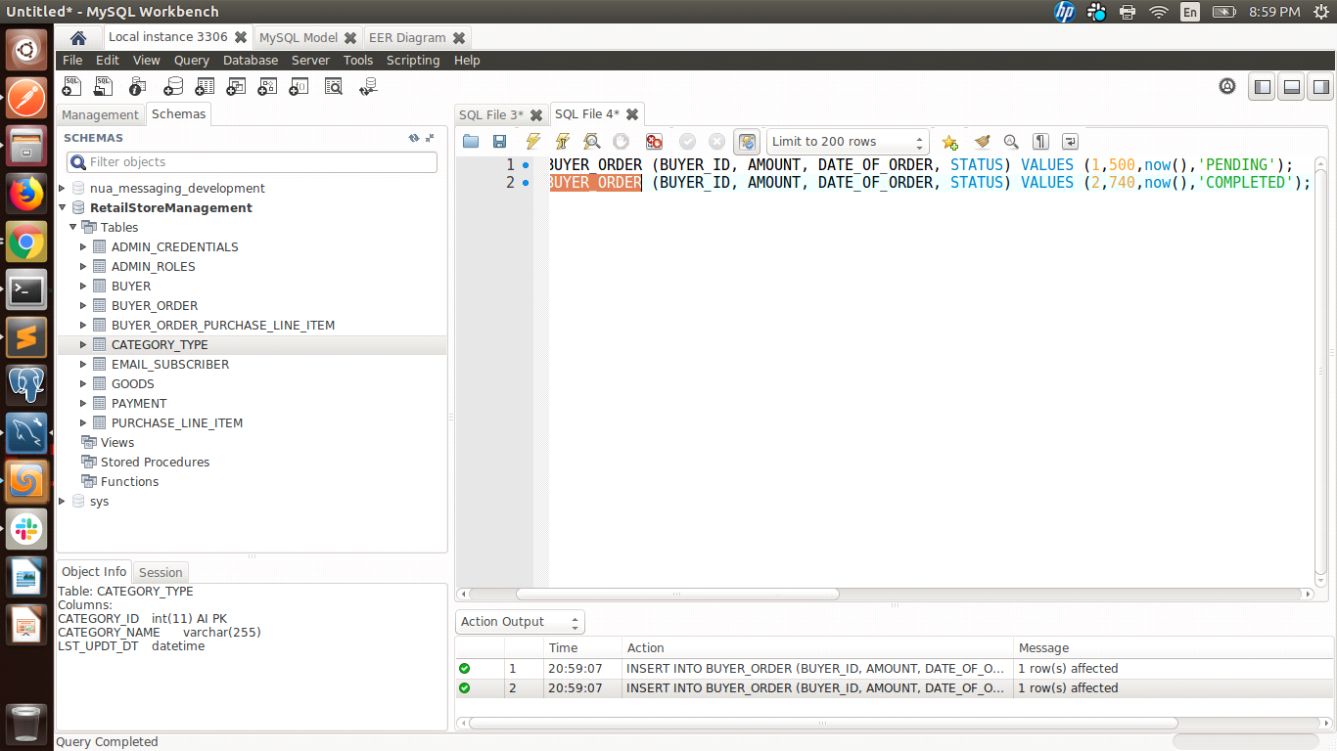

INSERT INTO PAYMENT (PAYMENT_AMOUNT ,PAYMENT_DATE ,PAYMENT_STATUS ,TRANSACTION_ID ,BUYER_ORDER_ID ,BUYER_ID) VALUES (500,now(),'COMPLETED','P1G12020',1,1);

INSERT INTO PAYMENT (PAYMENT_AMOUNT ,PAYMENT_DATE ,PAYMENT_STATUS ,TRANSACTION_ID ,BUYER_ORDER_ID ,BUYER_ID) VALUES (740,now(),'COMPLETED','P2G22020',1,1);

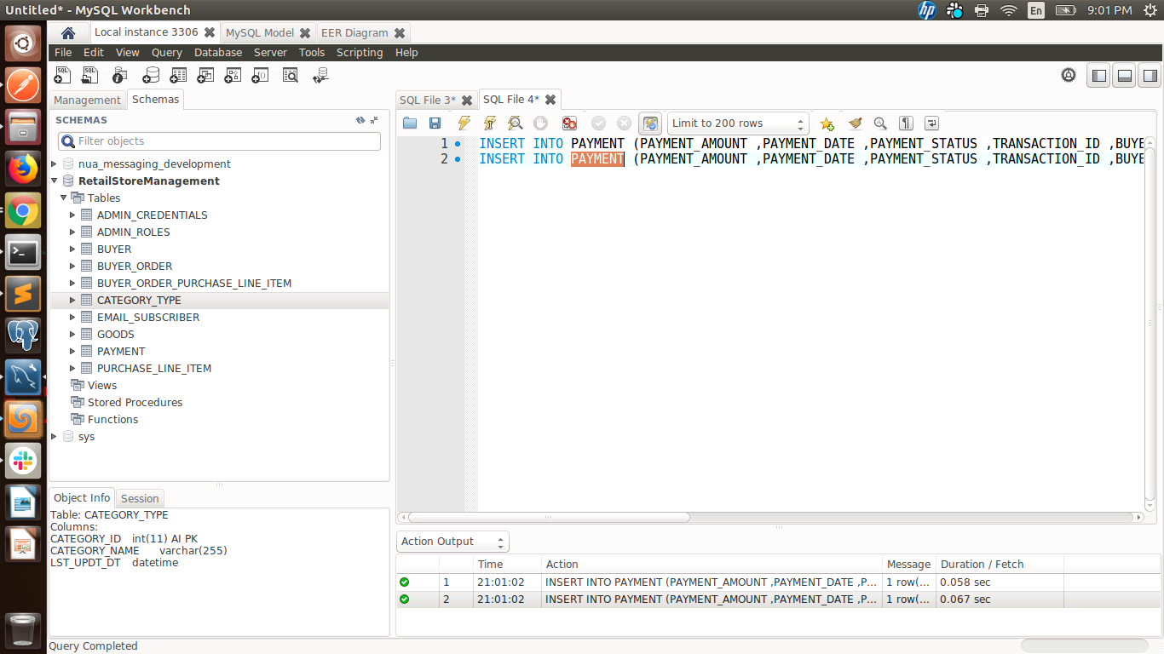

INSERT INTO ADMIN_ROLES (USER_NAME, ROLE_NAME) VALUES ('martha.n@gmail.com','BUYER');

INSERT INTO ADMIN_ROLES (USER_NAME, ROLE_NAME) VALUES ('jonas.k@gmail.com','BUYER');

INSERT INTO ADMIN_ROLES (USER_NAME, ROLE_NAME) VALUES ('admin1.n@gmail.com','ADMIN');

INSERT INTO ADMIN_ROLES (USER_NAME, ROLE_NAME) VALUES ('admin2.n@gmail.com','ADMIN');

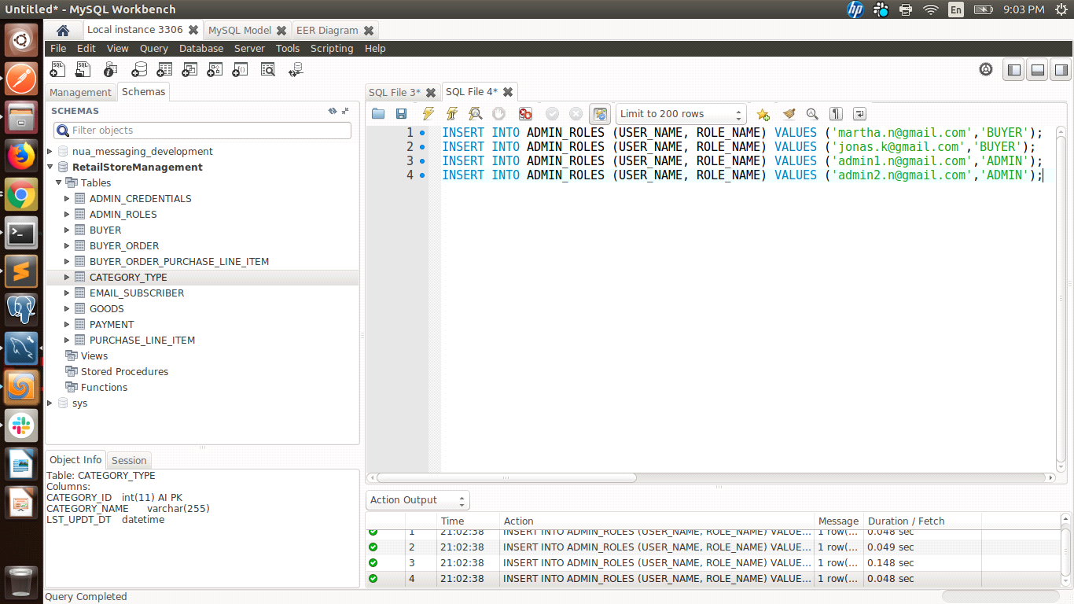

INSERT INTO ADMIN_CREDENTIALS (USER_NAME, PASSWORD) VALUES ('admin1.n@gmail.com','1nimda');

INSERT INTO ADMIN_CREDENTIALS (USER_NAME, PASSWORD) VALUES ('admin2.n@gmail.com','2nimda');

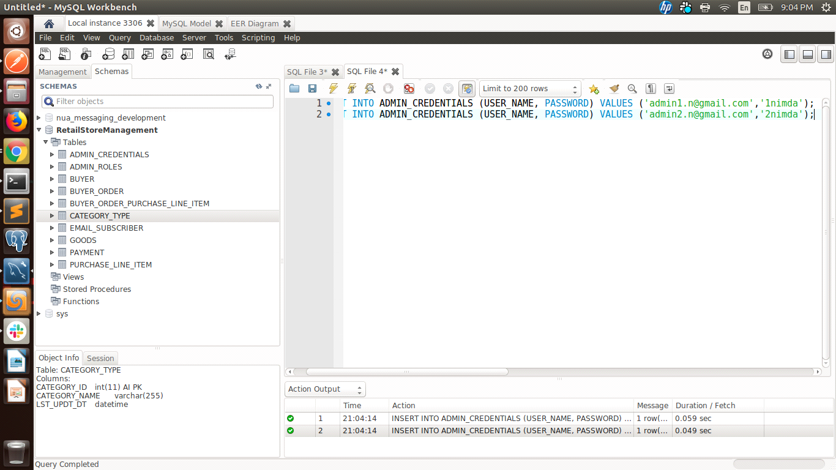

INSERT INTO EMAIL_SUBSCRIBER (EMAIL_ID, FIRST_NAME, LAST_NAME) VALUES ('martha.n@gmail.com','MARTHA', 'Nielsen');

INSERT INTO EMAIL_SUBSCRIBER (EMAIL_ID, FIRST_NAME, LAST_NAME) VALUES ('jonas.k@gmail.com','Jonas', 'Khanwald');

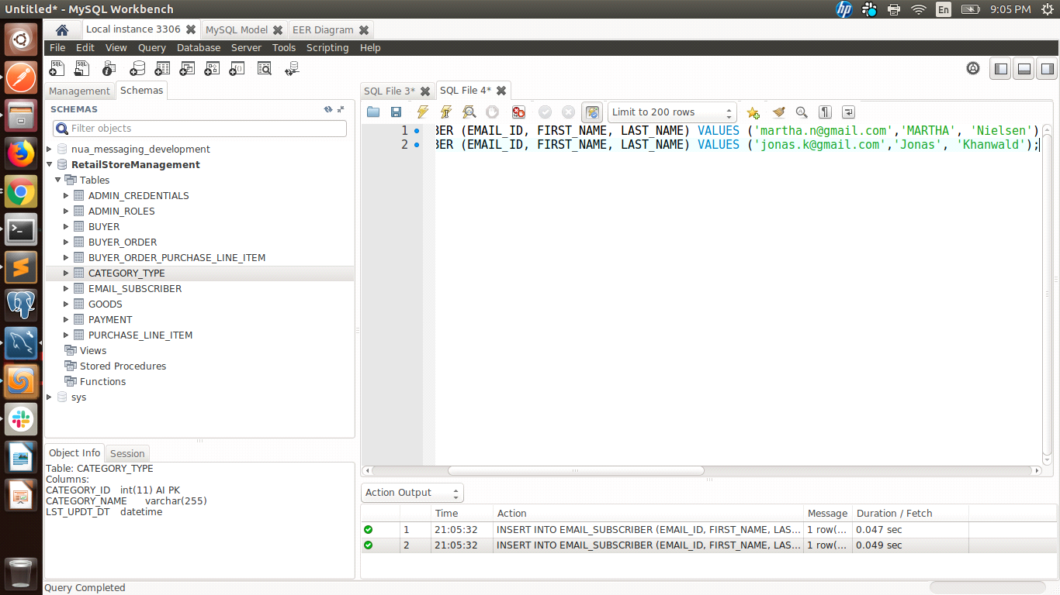

* **Delete:** delete one tuple or a set of tuples: from one table, from multiple tables.

* **Update:** update one tuple or a set of tuples: from one table, from multiple tables.

UPDATE PURCHASE_LINE_ITEM SET QUANTITY = 1 WHERE PURCHASE_LINE_ITEM_ID = 1;

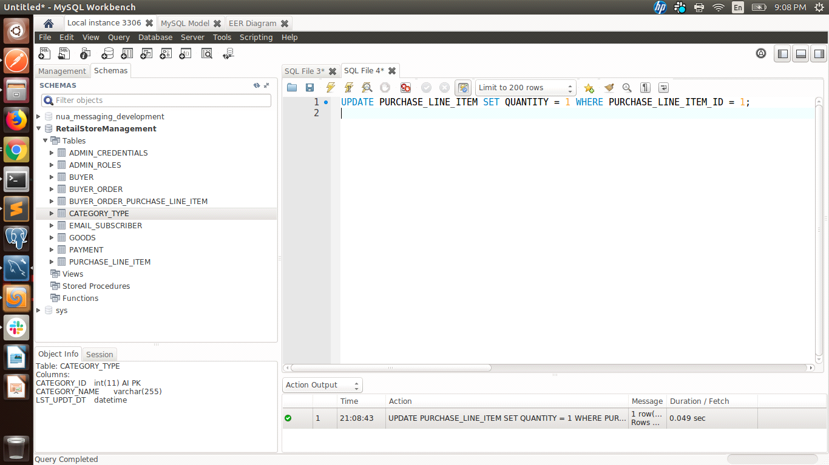

DELETE PURCHASE_LINE_ITEM WHERE PURCHASE_LINE_ITEM_ID = 1;

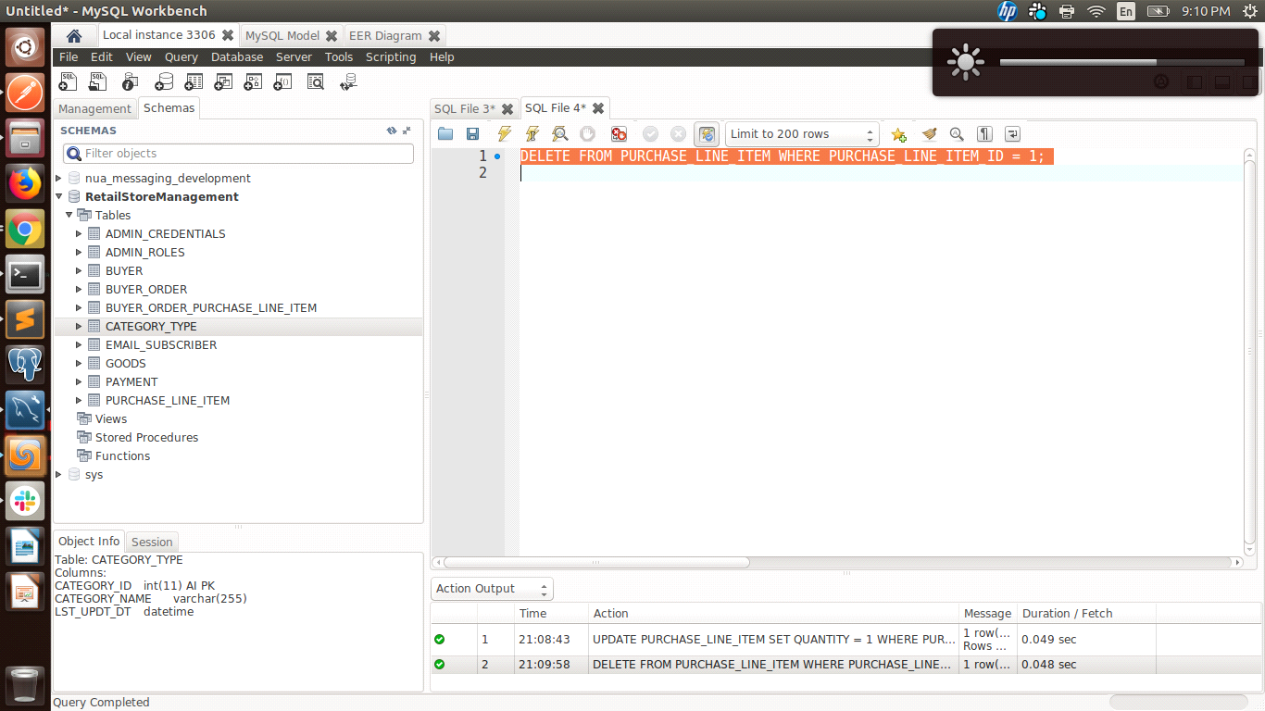

UPDATE BUYER_ORDER SET AMOUNT = 420 WHERE BUYER_ORDER_ID = 1;

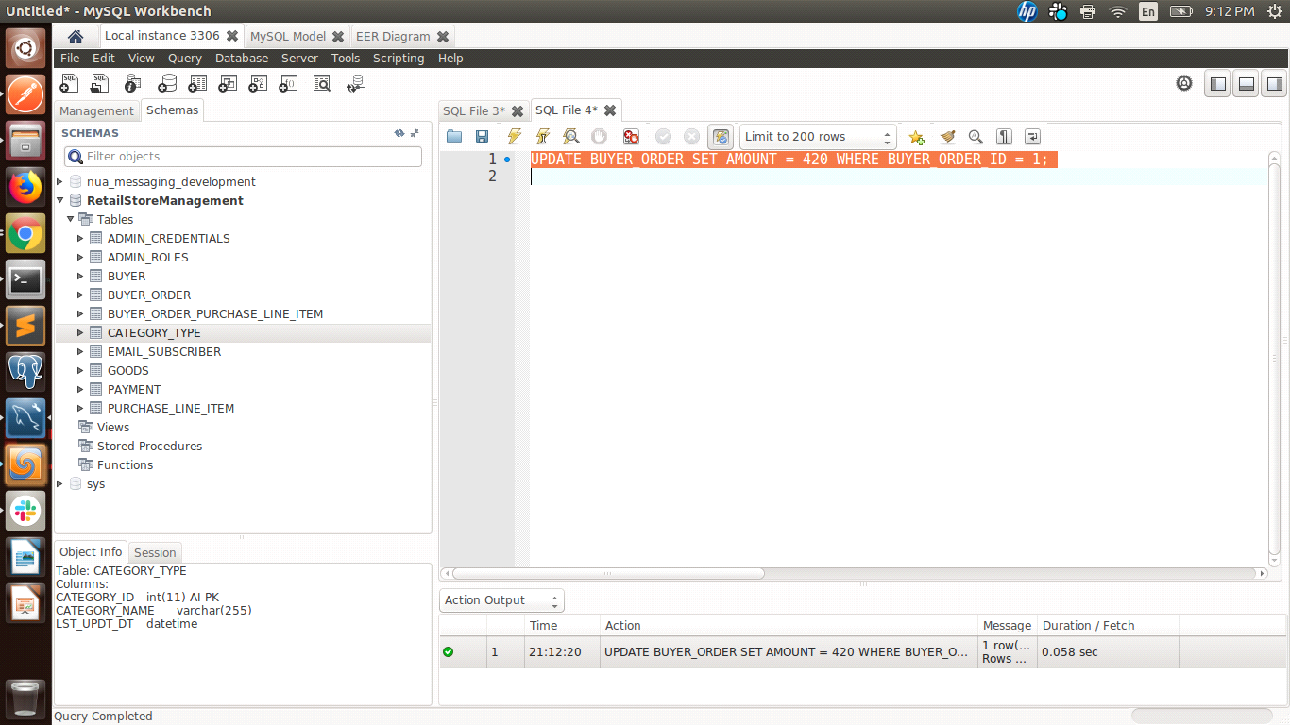

* **Create View:** - based on one relation and more than one relation:

operate on View (i.e., select, insert, delete, update,..)

CREATE VIEW GoodsView AS

SELECT GOODS_CODE, GOODS_DESCRIPTION,GOODS_AMOUNT,GOODS_NAME,GOODS_QUANTITY

FROM GOODS

WHERE GOODS_QUANTITY > 1;

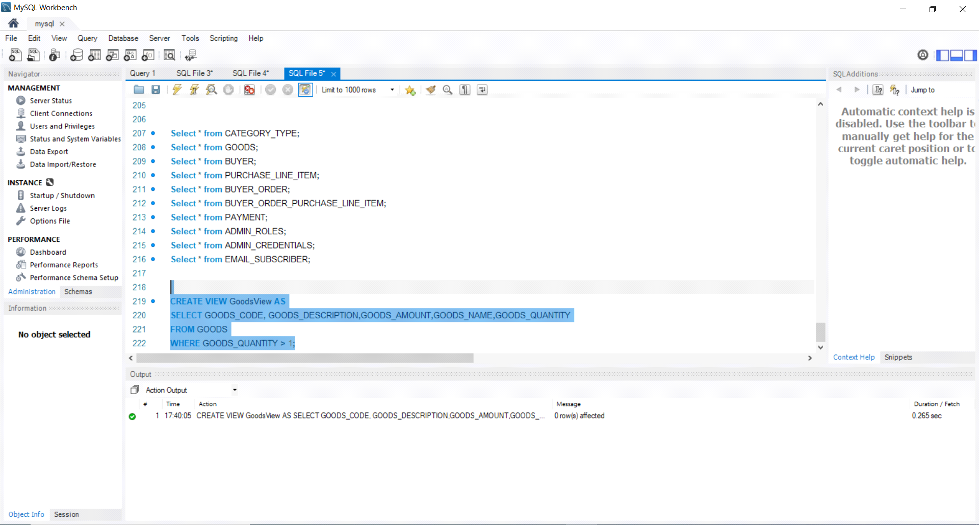

select * from GoodsView;

CREATE VIEW GoodsByCategoryView AS

select * from GOODS

Inner join CATEGORY_TYPE USING (CATEGORY_ID)

order by CATEGORY_NAME;

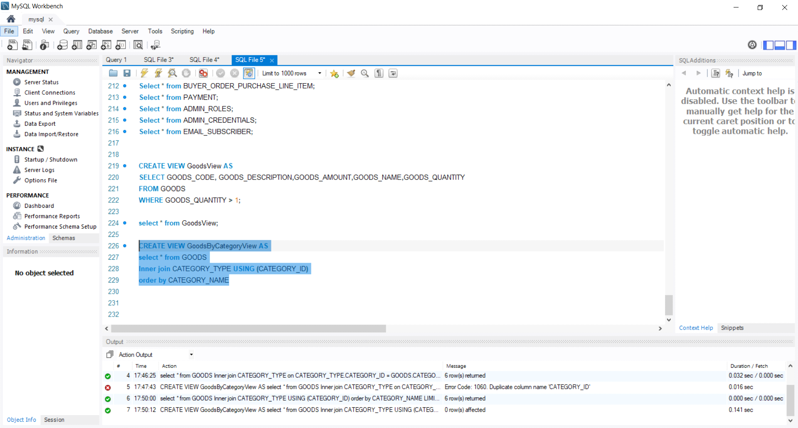

select * from GoodsByCategoryView;

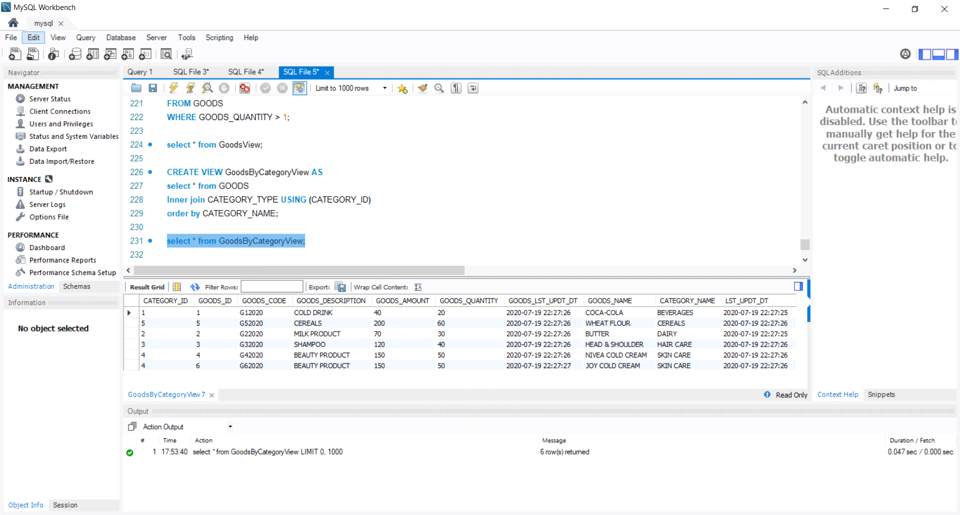

CREATE OR REPLACE VIEW GoodsByCategoryView AS

select * from GOODS

Inner join CATEGORY_TYPE USING (CATEGORY_ID)

where CATEGORY_NAME = 'BEVERAGES';

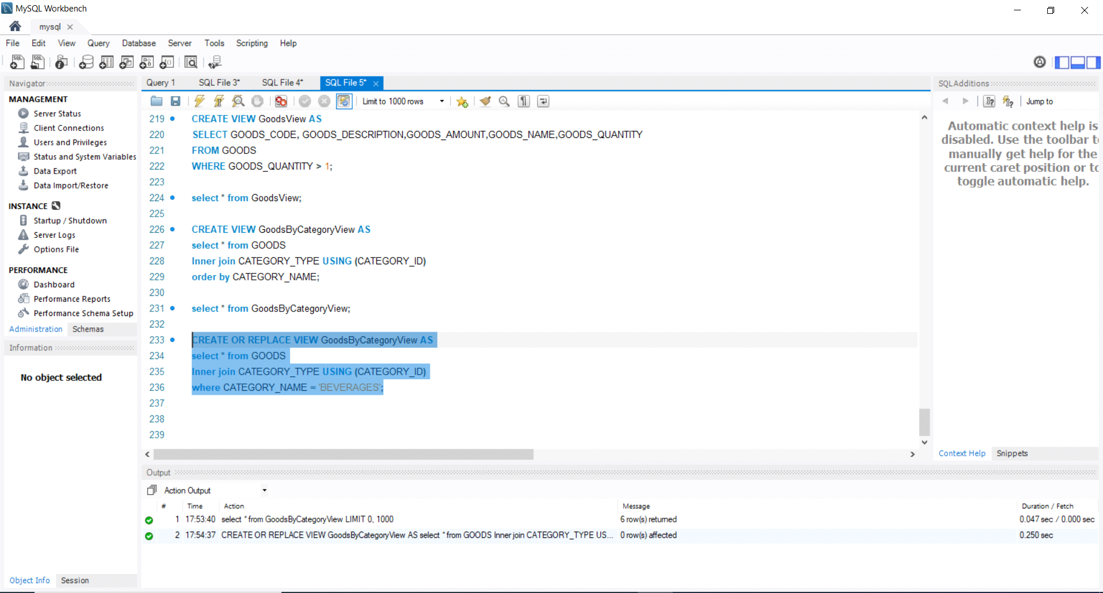

select * from GoodsByCategoryView;

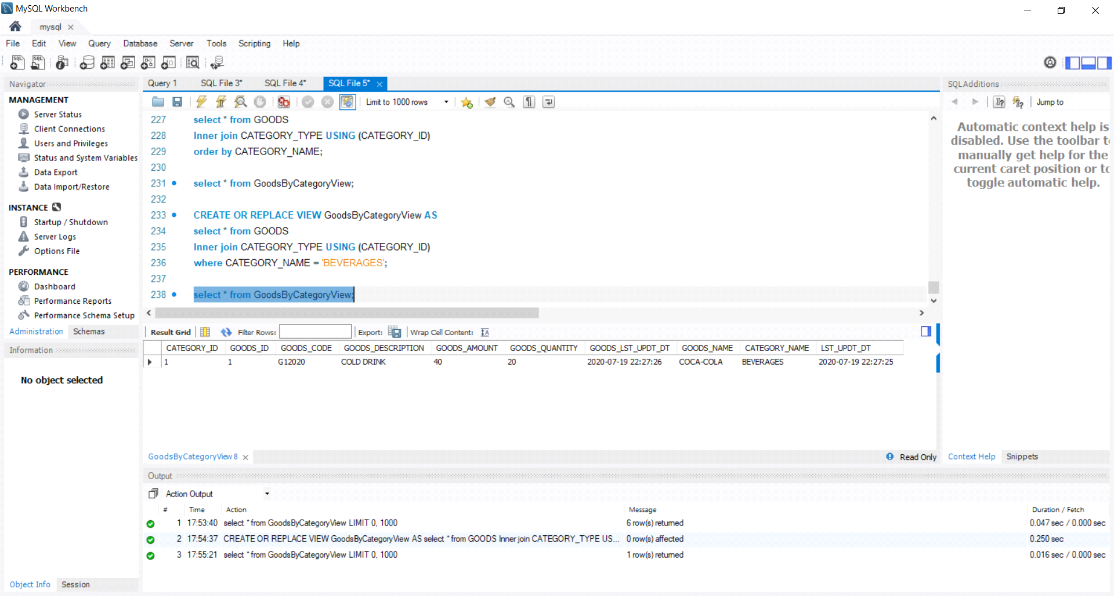

DROP VIEW view_name;



**B)** Also, create at least 4 different practical/useful triggers (written in MySQL) for your database to perform the following tasks:

* enforcing referential integrity
* enforcing attribute domain constraints
* creating database log - gathering statistics Etc.

DELIMITER $$

CREATE TRIGGER insert_goods

BEFORE INSERT

ON GOODS

FOR EACH ROW

BEGIN

IF (SELECT COUNT(*) FROM CATEGORY_TYPE WHERE CATEGORY_ID=new.CATEGORY_ID)= 0

THEN

INSERT error_msg VALUES ('Foreign Key Constraint Violated as mentioned CATEGORY_ID not present!');

END IF;

END $$

DELIMITER ;

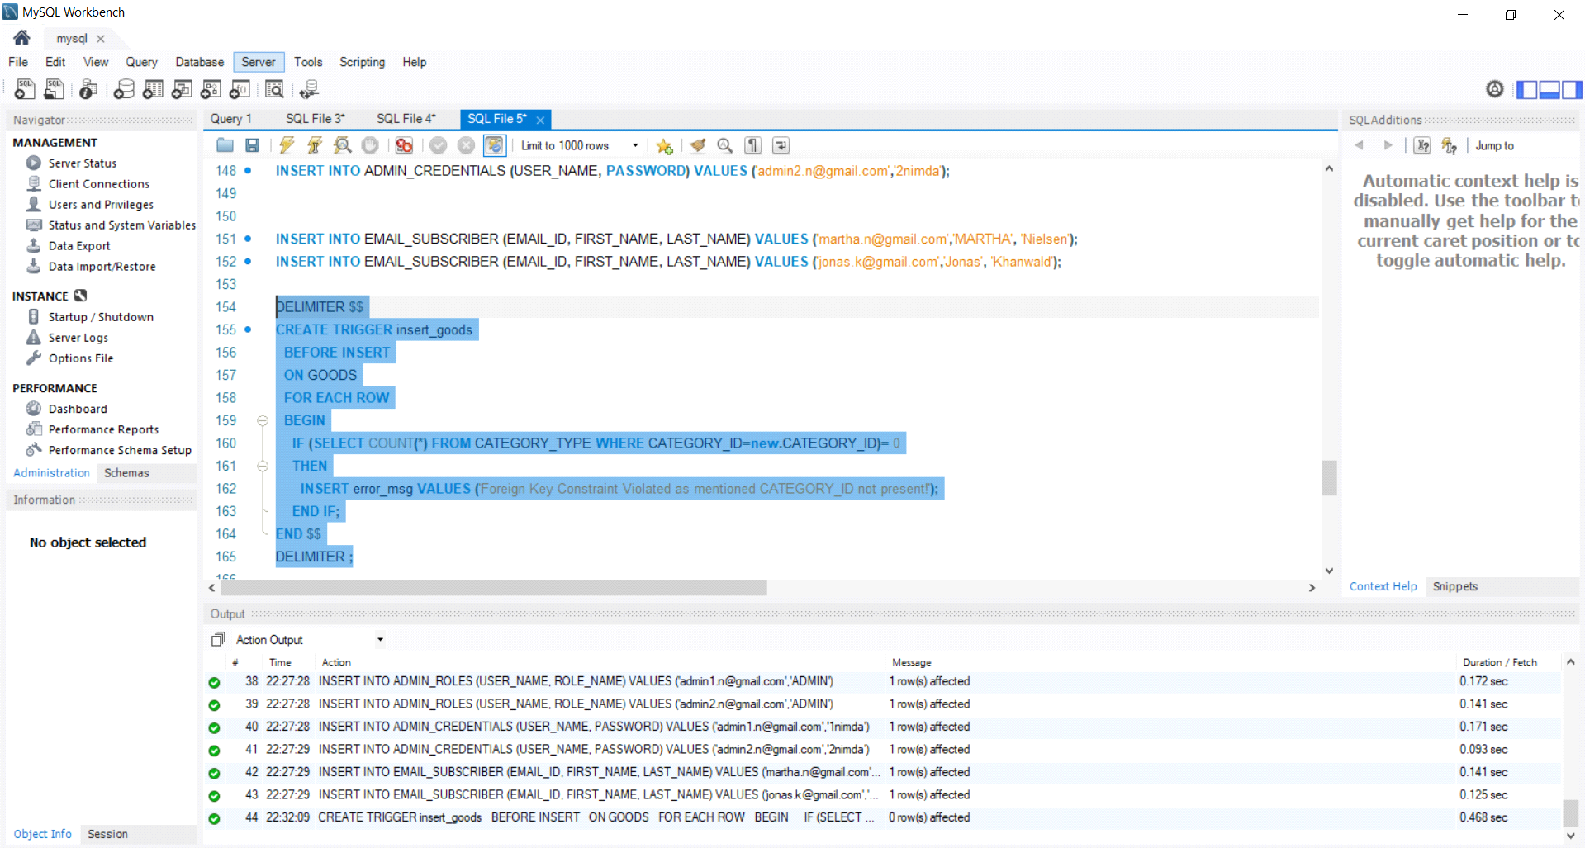

DELIMITER $$

CREATE TRIGGER insert_email_subscriber

BEFORE INSERT

ON EMAIL_SUBSCRIBER

FOR EACH ROW

BEGIN

IF (SELECT COUNT(*) FROM EMAIL_SUBSCRIBER WHERE EMAIl_ID=new.EMAIL_ID)= 0

THEN

INSERT error_msg VALUES ('Given Email ID is already subscribed');

END IF;

END $$

DELIMITER ;

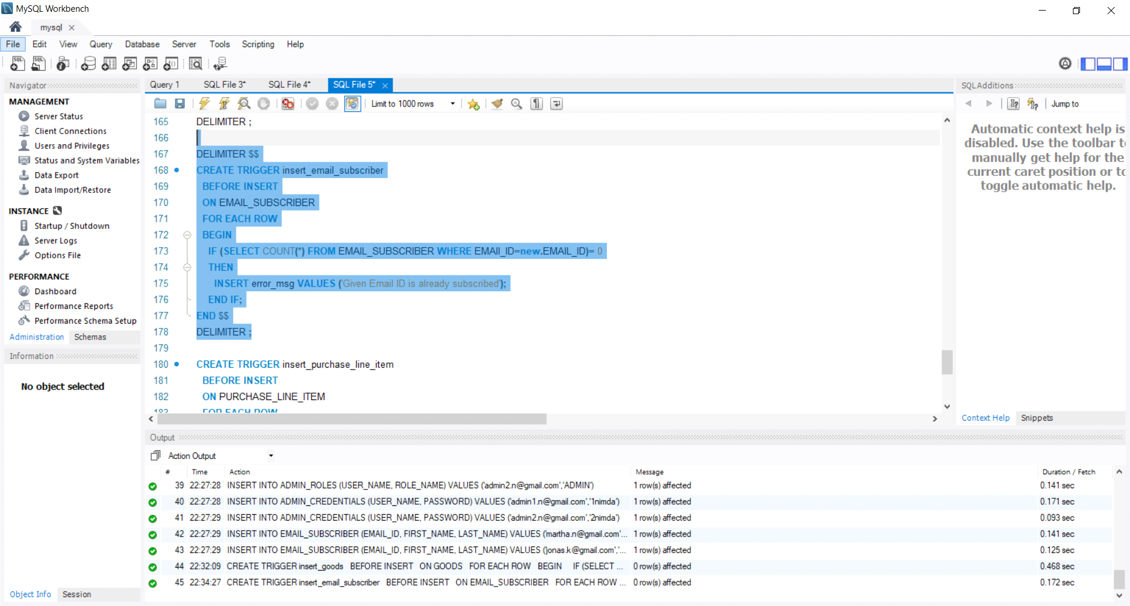

DELIMITER $$

CREATE TRIGGER insert_purchase_line_item

BEFORE INSERT

ON PURCHASE_LINE_ITEM

FOR EACH ROW

BEGIN

IF (SELECT GOODS_QUANTITY FROM GOODS WHERE GOODS_ID=new.GOODS_ID) >= new.QUANTITY

THEN

UPDATE GOODS SET GOODS_QUANTITY = GOODS_QUANTITY - new.QUANTITY WHERE GOODS_ID=new.GOODS_ID;

END IF;

END $$

DELIMITER ;

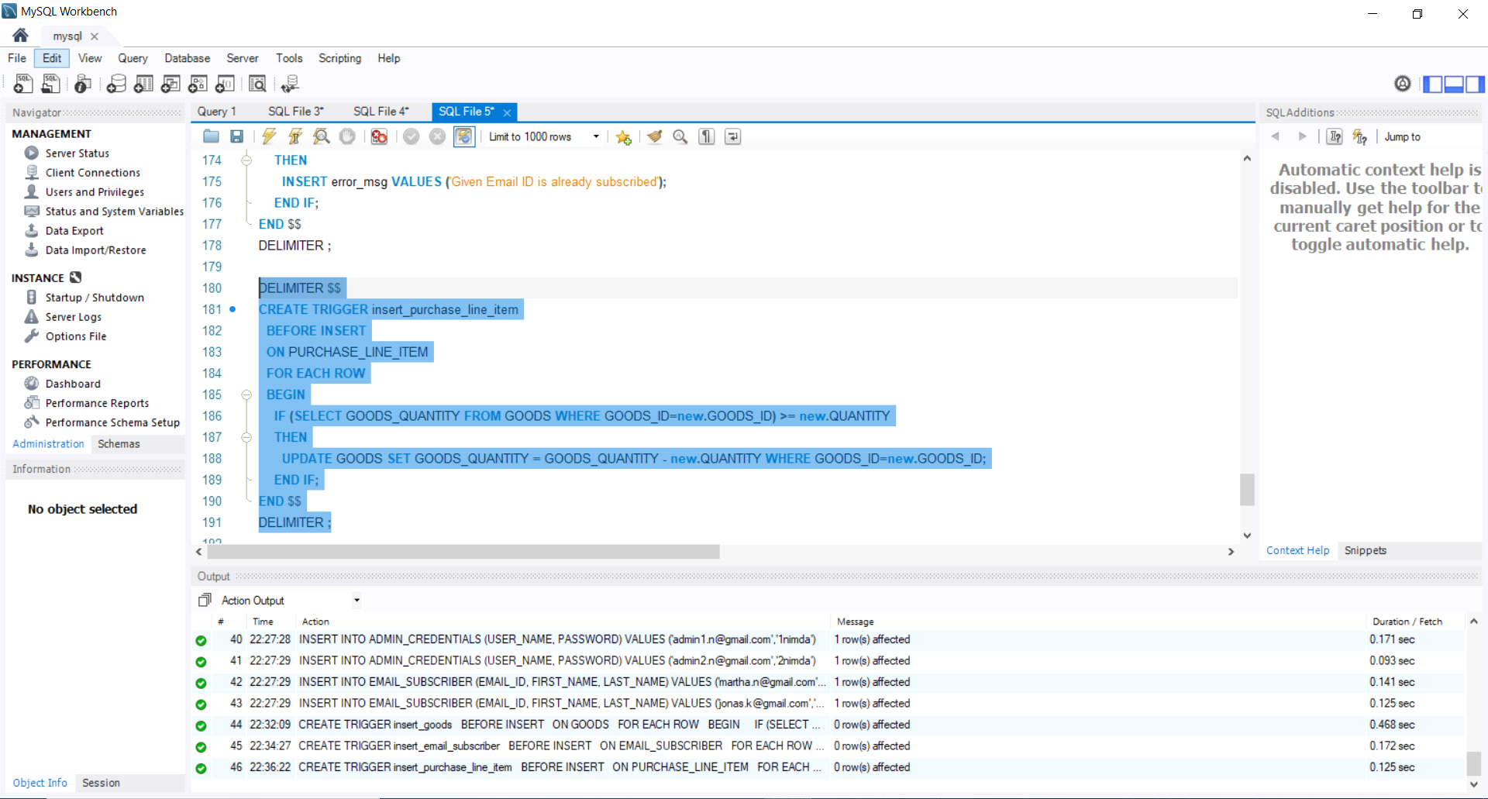

DELIMITER $$

CREATE TRIGGER insert_admin_credentials

BEFORE INSERT

ON ADMIN_CREDENTIALS

FOR EACH ROW

BEGIN

IF (SELECT COUNT(*) FROM ADMIN_ROLES WHERE USER_NAME=new.USER_NAME AND ROLE_NAME = 'ADMIN')= 0

THEN

INSERT error_msg VALUES ('Given User name is Not holding Admin Role');

END IF;

END $$

DELIMITER ;

